|  |  |
| --- | --- |
| **MMG**  **SW Detailed Design (DD)** | |
| **Summary** | This is the Software Detailed Design Document for the MMG component of *DAIMLER MMA* Project. |

|  |  |  |
| --- | --- | --- |
| **Author** | **Review** | **Approval** |
| SW Dev: Septimiu-Darex C. Vintila | See Project Master Document for the roles and Project Members List for the name of people | See Project Master Document for the roles and Project Members List for the name of people |
|  |  |  |
| **Distribution** | | |
| See Project Master Document for the roles and Project Members List for the name of people | See Project Master Document for the roles and Project Members List for the name of people | See Project Master Document for the roles and Project Members List for the name of people |

# Table of content

1.1. Revision history * 6

1.2. Purpose and Scope 6

1.3. Referenced documents 7

1.3.1. External documents 7

1.3.2. Internal Documents 7

1.3.3. Terminology and definitions 7

2.1. Overview 8

2.2. Traceability 8

3.1. Services 18

3.1.1. MMG_Init 18

3.1.2. MMG_runUpdateModeStatus 20

3.1.3. MMG_runManageModeDelays 21

3.1.4. MMG_runCheckModeStatus 22

3.1.5. mmg_UpdateModeStatus_CriticalAutotestsNok 23

3.1.6. mmg_UpdateModeStatus_PowerVoltageUnstable 24

3.1.7. mmg_UpdateModeStatus_ExecutedCycleDelay 25

3.1.8. mmg_UpdateModeStatus_ExecutedCycle 26

3.1.9. mmg_UpdateModeStatus_ExecutedTensioningCycle 27

3.1.10. mmg_UpdateModeStatus_BusOff 28

3.1.11. mmg_UpdateModeStatus_NoHallEffectSensor 29

3.1.12. mmg_UpdateModeStatus_DefaultValues 30

3.1.13. mmg_UpdateModeStatus_PowerSupply_AllCycles 31

3.1.14. mmg_UpdateModeStatus_EcuDefective_AllCycles 31

3.1.15. mmg_UpdateModeStatus_EOLComfort_BSR 32

3.1.16. mmg_UpdateModeStatus_ EOL_LowForce_TensioningCycles 32

3.1.17. mmg_UpdateModeStatus_Temperature_EOL_KL30_TensioningCycles 34

3.1.18. mmg_ManageModeDelays_ExecutedCycle 35

3.1.19. mmg_CheckIfCycleStepIsvalid 36

3.1.20. mmg_CheckCycleEnable 37

3.1.21. mmg_PreSafe_CopyStartData 37

3.1.22. mmg_PreSafe_CopyStopData 38

3.1.23. mmg_PreSafe_CopyStateData 39

3.1.24. mmg_PreSafe_HandleStateData 40

3.1.25. mmg_PreSafe_HandleStartData 41

3.1.26. mmg_PreSafe_HandleStopData 41

3.1.27. mmg_PreSafe_Init 42

3.1.28. MMG_runPreSafeRecorder 43

3.1.29. mmg_PreSafe_CheckEOLLimit 44

3.1.30. mmg_AvailabilityDataStatus 44

3.1.31. mmg_UpdateModeStatus_SignalReleaseInhibition 45

3.1.32. MMG_runUpdateNVMBlocks 46

3.1.33. mmg_CheckCodingOfAPI 46

3.1.34. mmg_CheckCodingRBTMFL 47

3.1.35. mmg_CheckCodingRBTMFR 48

3.1.36. mmg_CheckIgnitionON 48

3.2. Types 49

3.2.1. MMG_stModeDelayType 49

3.2.2. MMG_stModeConfigurationType 49

3.2.3. MMG_KU8_IDX 49

3.2.4. mmg_stPreSafeRecorderStartData 50

3.2.5. mmg_stPreSafeRecorderStopData 50

3.2.6. mmg_stPreSafeRecorderStateData 50

3.2.7. mmg_ stPreSafeRecorderManagement 50

3.3. Variables 51

3.3.1. mmg_b8MMGHAsBeenInitialized 51

3.3.2. MMG_u32ModesStatus 51

3.3.3. MMG_u32ModesStatusComplement 51

3.3.4. mmg_u16DelayToClearModeAfterCycle 51

3.3.5. MMG_u16MaxDelayAfterCycleActivation 51

3.3.6. MMG_astDelayAfterCycleThrsandModes 52

3.3.7. mmg_u8PrevHESModeStatus 52

3.3.8. mmg_stPreSafeManagement 52

3.3.9. mmg_stPreSafeStartData 52

3.3.10. mmg_stPreSafeStopData 52

3.3.11. mmg_stPreSafeStateData 53

3.3.12. mmg_stPreSafeInputData 53

3.3.13. mmg_u32DeficiencyLevel 53

3.3.14. mmg_u16LocalVoltage 53

3.3.15. mmg_TimeStamp 53

3.3.16. mmg_TimeUserData 53

3.3.17. mmg_u8Return 54

3.3.18. u8oldAvailabilityDataCategory 54

3.3.19. MMG_u16EnableCondition_Status 54

3.4. Macros 54

3.4.1. MMG_KU8_CYCLE_MODE_DELAY_INDEX 54

3.4.2. MMG_KU8_CYCLE_MODE_DELAY_UV_INDEX 54

3.4.3. MMG_KU8_NUMBER_OF_CYCLES_MODES_DELAYS 55

3.4.4. MMG_U32_INITIAL_VALUES_FOR_ALL_MODES 55

3.4.5. MMG_KU8_CFG_LAST_PRE_TENSIONING_CYCLE 55

3.4.6. MMG_KU8_CFG_BSR1_TENSIONING_CYCLE 55

3.4.7. MMG_KU8_CFG_HAPTIC_WARNING_10_CYCLE 55

3.4.8. MMG_KU8_CFG_HAPTIC_WARNING_41_CYCLE 56

3.4.9. MMG_KU8_CFG_PRODUCTION_0_CYCLE 56

3.4.10. MMG_KU8_CFG_PRODUCTION_1_CYCLE 56

3.4.11. MMG_KU16_TIMEOUT_INIT_VALUE 56

3.4.12. M_SET_MODE_MASK_OFF 56

3.4.13. M_SET_MODE_MASK_ON 56

3.4.14. MMG_KU8_NB_INHIB_AEC_ALL_CYCLES 57

3.4.15. MMG_KU8_IDX_POWERSUPPLY_OV 57

3.4.16. MMG_KU8_IDX_POWERSUPPLY_UV 57

3.4.17. MMG_KU8_NB_OF_INHIB_AEC_FOR_TENS_CYCLES 57

3.4.18. MMG_KU8_IDX_TEMPERATURE_HIGH 57

3.4.19. MMG_KU8_IDX_EOL_LOW_AND_HIGH 58

3.4.20. MMG_KU8_IDX_KL30_UV_TENS 58

3.4.21. MMG_KU8_IDX_KL30_OV_TENS 58

3.4.22. MMG_KU8_PRESF_TRIGGER_OFF 58

3.4.23. MMG_KU8_PRESF_TRIGGER_ON 58

3.4.24. MMG_KU8_State_DTC_Is_Not_Set 59

3.4.25. MMG_KU8_State_DTC_Is_Set 59

3.4.26. MMG_KU8_Tensioning_Successfull 59

3.4.27. MMG_KU8_Tensioning_NotStarted 59

3.4.28. MMG_KU8_Tensioning_Abort 59

3.4.29. MMG_KU8_Tensioning_NotDefined 59

3.4.30. MMG_KU8_SHIFT_BELT_HAND_OVER 60

3.4.31. MMG_KU8_SHIFT_IMPACTX 60

3.4.32. MMG_KU8_SHIFT_ROLLOVERTYPE1 60

3.4.33. MMG_KU8_SHIFT_ROLLOVERTYPE2 60

3.4.34. MMG_KU8_SHIFT_PRESAFE_DISABLED 60

3.4.35. MMG_KU8_SHIFT_PRESAFE_SUPP 61

3.4.36. MMG_KU8_SHIFT_PRESAFE_ABORT 61

3.4.37. MMG_KU8_SHIFT_KL15OFF 61

3.4.38. MMG_KU8_SHIFT_OV_OR_UV 61

3.4.39. MMG_KU8_SHIFT_PRESAFE_COUNTER 61

3.4.40. MMG_KU8_SHIFT_SYSTEM_FAILURE 61

3.4.41. MMG_KU8_VOLTAGE_DIV 62

3.4.42. MMG_KU16_VOLTAGE_MAX_VAL 62

3.4.43. MMG_KU32_DEF_LVL_LOW_THRS 62

3.4.44. MMG_KU32_DEF_LVL_MID_THRS 62

3.4.45. MMG_KU32_DEF_LVL_HIGH_THRS 62

3.4.46. MMG_KU32_DEF_LVL_HOT_THRS 63

3.4.47. MMG_KU16_SEC_TO_MILI 63

3.4.48. MMG_U16_CONVERT_TEMP_TO_RAW 63

3.4.49. KU8_MMG_ECU_SIDE_FRONT_LEFT 63

3.4.50. KU8_MMG_ECU_SIDE_FRONT_RIGHT 63

3.4.51. KU8_MMG_ECU_LOCATION 63

3.4.52. KU8_MMG_PRESAFE_RECORDER_1_ID 64

3.4.53. KU8_MMG_PRESAFE_RECORDER_2_ID 64

3.4.54. MMG_KU32_AEC_MASK_GREEN_STATUS 64

3.4.55. MMG_KU32_AEC_MASK_RED_STATUS 64

3.4.56. MMG_STATUS_IS_GREEN 65

3.4.57. MMG_STATUS_IS_RED 65

3.4.58. MMG_STATUS_IS_DEFAULT 65

3.4.59. MMG_KU8_IDX_IMPL_BUCKLE_TENS 65

3.4.60. MMG_KU8_IDX_TIMOEUT_BUCKLEK_TENS 65

3.4.61. MMG_KU8_CFG_BSR3_TENSIONING_CYCLE 66

3.4.62. KU32_MMG_VEH_EQP_CYCLE_ENABLE 66

3.4.63. KU32_MMG_AEC_GROUP_MASK 66

3.4.64. BOOL_MMG_CLEAR_ENABLE_CONDITION 66

3.4.65. BOOL_MMG_SET_ENABLE_CONDITION 67

3.4.66. MMG_SET_ENABLE_CONDITION_MASK_OFF(mask) 67

3.4.67. MMG_SET_ENABLE_CONDITION_MASK_ON(mask) 67

# Tables of figures

Figure 1: MMG_Init diagram 20

Figure 2: MMG_runUpdateModeStatus diagram 21

Figure 3: MMG_runManageModeDelays diagram 22

Figure 4: MMG_runCheckModeStatus diagram 23

Figure 5: mmg_UpdateModeStatus_CriticalAutotestsNok diagram 24

Figure 6: mmg_UpdateModeStatus_PowerVoltageUnstable diagram 25

Figure 7: mmg_UpdateModeStatus_ExecutedCycleDelay diagram 26

Figure 8: mmg_UpdateModeStatus_ExecutedCycle diagram 27

Figure 9: mmg_UpdateModeStatus_ExecutedTensioningCycle diagram 28

Figure 10: mmg_UpdateModeStatus_BusOff diagram 29

Figure 11 mmg_UpdateModeStatus_ NoHallEffectSensor f diagram 30

Figure 12 mmg_UpdateModeStatus_DefaultValues diagram 31

Figure 13 mmg_UpdateModeStatus_PowerSupply_AllCycles: 31

Figure 14 mmg_UpdateModeStatus_EcuDefective_AllCycles 32

Figure 15 mmg_UpdateModeStatus_EOLComfort_BSR 32

Figure 16: mmg_UpdateModeStatus_ EOL_LowForce_TensioningCycles 34

Figure 17: mmg_UpdateModeStatus_Temperature_EOL_KL30_TensioningCycles 35

Figure 18: mmg_ManageModeDelays_ExecutedCycle diagram 36

Figure 19: mmg_CheckIfCycleStepIsvalid diagram 37

Figure 20: mmg_CheckCycleEnable diagram 37

Figure 21: mmg_PreSafe_CopyStartData 38

Figure 22: mmg_PreSafe_CopyStopData 39

Figure 23: mmg_PreSafe_CopyStateData 40

Figure 24: Part1 mmg_PreSafe_HandleStateData 41

Figure 25: Part2 mmg_PreSafe_HandleStateData 41

Figure 26: Part1 mmg_PreSafe_HandleStartData 41

Figure 27: Part2 mmg_PreSafe_HandleStartData 41

Figure 28: Part1 mmg_PreSafe_HandleStopData 42

Figure 29: Part1 mmg_PreSafe_HandleStopData 42

Figure 30: mmg_PreSafe_Init 43

Figure 31: Part1 MMG_runPreSafeRecorder 43

Figure 32: Part2 MMG_runPreSafeRecorder 43

Figure 33: Part3 MMG_runPreSafeRecorder 44

Figure 34: mmg_PreSafe_CheckEOLLimit 44

Figure 35: mmg_AvailabilityDataStatus 45

Figure 36mmg_UpdateModeStatus_SignalReleaseInhibition 46

Figure 37MMG_runUpdateNVMBlocks 46

Figure 38 Check coding of API 47

Figure 39 Check coding of RBTMFL 48

Figure 40 Check coding of RBTMFR 48

Figure 41 Check Ignition status 49

# General Information

## Revision history *

|  |  |  |  |
| --- | --- | --- | --- |
| **Revision** | **Date** | **Author(s)** | **Description/comment** |
| 1.1.4.1 | 04.02.2022 | Septimiu-Darex C. Vintila | Initial revision. |
| 1.1.4.2 | 04.02.2022 | Septimiu-Darex C. Vintila | Design fixes after review. |
| 1.1.4.3 | 08.02.2022 | Septimiu-Darex C. Vintila | Traceability added. |
| 1.1.4.4 | 15.02.2022 | Septimiu-Darex C. Vintila | Requirements fixed. |
| 1.1.4.5 | 10.03.2022 | Andreea Negrea | Add check for validity of cycles. |
| 1.1.4.6 | 17.03.2022 | Andreea Negrea | Add fix after review. |
| 1.1,4.7 | 29.03.2022 | Mirela Obada | Update traceabilty. |
| 1.1.4.8 | 29.03.2022 | Mirela Obada | Update document. |
| 1.1.4.9 | 11.04.2022 | Mirela Obada | Fix findings from review. |
| 1.1.4.10 | 14.06.2022 | Mirela Obada | Add traceability and update of figures. |
| 1.1.4.11 | 17.06.2022 | Mirela Obada | Update after review. |
| 1.1.4.12 | 20.06.2022 | Mirela Obada | Update functions template. |
| 1.1.4.13 | 21.06.2022 | Mirela Obada | Update tabel of content. |
| 1.1.4.14 | 21.06.2022 | Mirela Obada | Update version of document. |
| 1.1.4.15 | 22.06.2022 | Mirela Obada | Update traceability. |
| 1.1.4.16 | 22.06.2022 | Mirela Obada | Update revision history. |
| 1.1.4.17 | 22.06.2022 | Mirela Obada | Modify requirement 0042 because it was doubled. |
| 1.1.4.18 | 31.08.2022 | Stefan Dominte | Update for 3.0 release. |
| 1.1.4.19 | 15.11.2022 | Stefan Dominte | Update for 4.0 release. |
| 1.1.4.20 | 22.11.2022 | Stefan Dominte | Update after review. |
| 1.1.4.21 | 19.01.2023 | Andreea Negrea | Update with 5.0 belt functionality |
| 1.1.4.22 | 09.02.2023 | Stefan Dominte | Update with 5.0 presafe recorder |
| 1.1.4.23 | 13.02.2023 | Tudor Gligor | Update with 5.0 AvailabilityDataStatus |
| 1.1.4.24 | 15.02.2023 | Stefan Dominte | Update after review |
| 1.1.4.25 | 20.02.2023 | Stefan Dominte | Traceabilty update |
| 1.1.4.26 | 21.02.2023 | Stefan Dominte | Traceabilty re-update |
| 1.1.4.27 | 02.03.2023 | Andreea Negrea | Update with new context for EOL Low Force |
| 1.1.4.28 | 06.03.2023 | Stefan Dominte | Update for R5.1z |
| 1.1.4.29 | 07.03.2023 | Stefan Dominte | Update with inhibiton context for pyro activation |
| 1.1.4.30 | 08.03.2023 | Stefan Dominte | Update after review |
| 1.1.4.31 | 05.05.2023 | Andreea Negrea | Update for 6.0 |
| 1.1.4.32 | 20/06/2023 | Madalina Serban | Update for 6.1 |
| 1.1.4.33 | 21/06/2023 | Madalina Serban | Updated traceability |
| 1.1.4.34 | 22/06/2023 | Madalina Serban | Updated traceability |
| 1.1.4.35 | 22/06/2023 | Madalina Serban | Updated internal document version |
| 1.1.4.36 | 30/08/2023 | Mirela Obada | Update for R7.0 release |
| 1.1.4.37 | 06/10/2023 | Tudor Gligor | Update mmg_AvailabilityDataStatus |
| 1.1.4.38 | 13/10/2023 | Madalina Serban | Updated diagrams |
| 1.1.4.39 | 19/01/2024 | Mirela Obada | Update for 8.1 |
| 1.1.4.40 | 29/01/2024 | Mirela Obada | Update after SRM |

*\* Template history is found in the CM tool used for templates*

## Purpose and Scope

The purpose of this document is to establish the functionality and behavior of the MMG component

## Referenced documents

### External documents

|  |  |  |
| --- | --- | --- |
| **Id** | **Title** | **Reference** |
|  |  |  |
|  |  |  |
|  |  |  |

### Internal Documents

|  |  |  |
| --- | --- | --- |
| **Id** | **Title** | **Reference** |
|  |  |  |
|  |  |  |
|  |  |  |
|  |  |  |

### 1.3.3. Terminology and definitions

The generic acronyms are available in the [AEM process and method wiki](https://alvteams.alv.autoliv.int/sites/aeuaeequalityassurance/AEM%20Process%20wiki/acronyms.aspx)

|  |  |
| --- | --- |
| **Terminology** | **Meaning** |
| AAU | Atomic architectural unit |
| SW | software |
| MMG | Mode ManaGement |

# SW atomic architectural unit design

## Overview

Purpose of the MMG component is to:

* Gather data from other components and calculate the overall status of the system.
* Communicate to other components the status of the system
* Determine at Init if available tensioning cycles are valid or not (different from 0xFF)
* Gather data from other components in order to populate PreSafe Recorder with specific information
* Gather data from other components to populate the RoELite structure with Availability Data

**MMG**

Scheduler

**PAL**

**PMP**

MMG_Init()

MMG_runUpdateModeStatus()

MMG_runAutotestCall10ms()MMG_runAutotestCall100ms()

MMG_runManageModeDelays()

MMG_runMainFunction()

PAL_Autotest_CheckHWSelfProtection()

PAL_Autotest_CheckMotorCurrent()

PAL_Autotest_CheckMotorThermalProtection()

PMP_Autotest_CheckPowerSupplyOV()

PMP_Autotest_CheckPowerSupplyUV()

DEM

DEM_SetEventStatus()

DEM_GetEventStatus()

**BFE**

**PRE**

**SFR**

MMG_runCheckModeStatus()

BFE_ReadExecutedCycle()

MMG_runGetTestResult()

MMG_runGetTestResult()

## Traceability

|  |  |  |  |
| --- | --- | --- | --- |
| Requirements | Criteria | Linked Runnable | Source |
| DSG_MMG_0001 | The “Critical auto tests NOK” mode shall be updated every 10 ms based on the available information. | MMG_runUpdateModeStatus | ARCH_SW_MMG_0004 |
| DSG_MMG_0002 | The “Power voltage unstable” mode shall be updated every 10 ms based on the available information. | MMG_runUpdateModeStatus | ARCH_SW_MMG_0004 |
| DSG_MMG_0003 | The “Executed cycle with delay” modes shall be updated every 10 ms based on the available information. | MMG_runUpdateModeStatus | ARCH_SW_MMG_0004 |
| DSG_MMG_0004 | The “Executed cycle” mode shall be updated every 10 ms based on the available information. | MMG_runUpdateModeStatus | ARCH_SW_MMG_0004 |
| DSG_MMG_0005 | The “Executed tensioning cycle” mode shall be updated every 10 ms based on the available information. | MMG_runUpdateModeStatus | ARCH_SW_MMG_0004 |
| DSG_MMG_0007 | The “No hall effect sensor” mode shall be updated every 10 ms based on the available information. | MMG_runUpdateModeStatus | ARCH_SW_MMG_0004 |
| DSG_MMG_0008 | The “Inhibition of all cycles” mode shall be updated every 10 ms based on the available information. | MMG_runUpdateModeStatus | ARCH_SW_MMG_0004 |
| DSG_MMG_0009 | The “Inhibition of all cycles by ecu defect” mode shall be updated every 10 ms based on the available information. | MMG_runUpdateModeStatus | ARCH_SW_MMG_0004 |
| DSG_MMG_0010 | The “EOL counter inhibition” mode shall be updated every 10 ms based on the available information. | MMG_runUpdateModeStatus | ARCH_SW_MMG_0004 |
| DSG_MMG_0011 | The “Inhibition of tensioning” mode shall be updated every 10 ms based on the available information. | MMG_runUpdateModeStatus | ARCH_SW_MMG_0004 |
| DSG_MMG_0012 | The delays for the executed cycles shall be updated every 10 ms. | MMG_runManageModeDelays | ARCH_SW_MMG_0007 |
| DSG_MMG_0013 | The status for all modes shall be available on request. | MMG_runCheckModeStatus | ARCH_SW_MMG_0006 |
| DSG_MMG_0014 | At INIT all cycles shall be checked to have at least one step different from 0xFF. | MMG_Init() | ARCH_SW_MMG_0008; |
| DSG_MMG_0015 | At INIT first steps shall be checked to have first byte different from 0xFF. | MMG_Init() | ARCH_SW_MMG_0008; |
| DSG_MMG_0016 | If MMG has been initialized local variable MMG_b8MMGHAsBeenInitialized is B_TRUE) the contexts will be periodically updated. | MMG_runUpdateModeStatus | ARCH_SW_MMG_0004; |
| DSG_MMG_0017 | **mmg_UpdateModeStatus_CriticalAutotestsNok** local function will read the startup Autotest status for setting the MMG_KU32_MASK_CRITICAL_AT_NOT context. | MMG_runUpdateModeStatus | ARCH_SW_MMG_0250 |
| DSG_MMG_0018 | **mmg_UpdateModeStatus_PowerVoltageUnstable** local function will read the Battery voltage survey status for setting the MMG_KU32_MASK_POWER_VOLTAGE_UNSTABLE context. | MMG_runUpdateModeStatus | ARCH_SW_MMG_0251 |
| DSG_MMG_0019 | **mmg_UpdateModeStatus_ExecutedCycleDelay** local function will read the executed cycle delay status for setting the MMG_KU32_MASK_NO_BELTFUNCTIONS_DELAY context. | MMG_runUpdateModeStatus | ARCH_SW_MMG_0252 |
| DSG_MMG_0020 | **mmg_UpdateModeStatus_ExecutedCycle** local function will read the current execute cycle and pyro activation status for setting the MMG_KU32_MASK_NO_BELTFUNCTIONS context. | MMG_runUpdateModeStatus | ARCH_SW_MMG_0253; ARCH_SW_MMG_0254 |
| DSG_MMG_0021 | **mmg_UpdateModeStatus_NoHallEffectSensor** local function will read the Hall Efect Sensor AEC status for setting the MMG_KU32_MASK_NO_HALL_EFFECT_SENSOR context. | MMG_runUpdateModeStatus | ARCH_SW_MMG_0140; ARCH_SW_MMG_0205 |
| DSG_MMG_0022 | **mmg_UpdateModeStatus_PowerSupply_AllCycles** local function will compute the NVP_stVehicleEquipmentData. Undervoltage and NVP_stVehicleEquipmentData.Overvoltage variables in order to set the MMG_KU32_MASK_AEC_ECU_DEFECT_ALL_CYCLES context. | MMG_runUpdateModeStatus | ARCH_SW_MMG_0150; ARCH_SW_MMG_0151 |
| DSG_MMG_0023 | **mmg_UpdateModeStatus_EcuDefective_AllCycles** local function will read the AEC group status and check if Group mask hardware AEC is set in order to compute MMG_KU32_MASK_AEC_ECU_DEFECT_ALL_CYCLES context. | MMG_runUpdateModeStatus | ARCH_SW_MMG_0152; ARCH_SW_MMG_0205 |
| DSG_MMG_0024 | **mmg_UpdateModeStatus_EcuDefective_AllCycles** local function will read the AEC group status and check if Group SW/HW Self protection status AEC is set in order to compute MMG_KU32_MASK_AEC_ECU_DEFECT_ALL_CYCLES context. | MMG_runUpdateModeStatus | ARCH_SW_MMG_0153 |
| DSG_MMG_0025 | **mmg_UpdateModeStatus_Temperature_EOL_KL30_TensioningCycles** local function will read the AEC group status and check if Temperature high AEC is set in order to compute MMG_KU32_MASK_AEC_INHIB_TENSIONING_CYCLES context. | MMG_runUpdateModeStatus | ARCH_SW_MMG_0133; ARCH_SW_MMG_0205 |
| DSG_MMG_0026 | **mmg_UpdateModeStatus_Temperature_EOL_KL30_TensioningCycles** local function will read the AEC group status and check if EOL low and high AEC is set in order to compute MMG_KU32_MASK_AEC_INHIB_TENSIONING_CYCLES context. | MMG_runUpdateModeStatus | ARCH_SW_MMG_0205 |
| DSG_MMG_0114 | **mmg_UpdateModeStatus_EOL_Low_Force** function will read the AEC group status and check if EOL low and high AEC is set in order to compute MMG_KU32_MASK_EOL_LOW_FORCE | MMG_runUpdateModeStatus | ARCH_SW_MMG_0138; |
| DSG_MMG_0027 | **mmg_UpdateModeStatus_Temperature_EOL_KL30_TensioningCycles** local function will compute NVP_stVehicleEquipmentData.UndervoltageAbort variable in order to set MMG_KU32_MASK_AEC_INHIB_TENSIONING_CYCLES context. | MMG_runUpdateModeStatus | ARCH_SW_MMG_0135 |
| DSG_MMG_0028 | **mmg_UpdateModeStatus_Temperature_EOL_KL30_TensioningCycles** local function will compute the NVP_stVehicleEquipmentData.OvervoltageAbort in order to set the MMG_KU32_MASK_AEC_INHIB_TENSIONING_CYCLES context. | MMG_runUpdateModeStatus | ARCH_SW_MMG_0157 |
| DSG_MMG_0029 | **mmg_UpdateModeStatus_Temperature_EOL_KL30_TensioningCycles** local function will read the AEC group status and check if implausible data for buckle signal AEC is set in order to compute MMG_KU32_MASK_AEC_INHIB_TENSIONING_CYCLES context. | MMG_runUpdateModeStatus | ARCH_SW_MMG_0158 |
| DSG_MMG_0030 | **mmg_UpdateModeStatus_Temperature_EOL_KL30_TensioningCycles** local function will read the AEC group status and check if timeout for buckle signal AEC is set in order to compute MMG_KU32_MASK_AEC_INHIB_TENSIONING_CYCLES context. | MMG_runUpdateModeStatus | ARCH_SW_MMG_0159 |
| DSG_MMG_0031 | **mmg_UpdateModeStatus_Temperature_EOL_KL30_TensioningCycles** local function will read the AEC group status and check if control steering configuration AEC is set in order to compute MMG_KU32_MASK_AEC_INHIB_TENSIONING_CYCLES context. | MMG_runUpdateModeStatus | ARCH_SW_MMG_0160 |
| DSG_MMG_0032 | **mmg_UpdateModeStatus_EOLComfort_BSR** local function will read the AEC group status and check if EOL comfort AEC is set in order to compute MMG_KU32_MASK_EOL_COUNTER_INHIBITION context. | MMG_runUpdateModeStatus | ARCH_SW_MMG_0162; ARCH_SW_MMG_0205 |
| DSG_MMG_0033 | **mmg_UpdateModeStatus_CriticalAutotestsNok** local function will read the last critical autotest ID as an input. | MMG_runUpdateModeStatus | ARCH_SW_MMG_0200 |
| DSG_MMG_0034 | **mmg_UpdateModeStatus_CriticalAutotestsNok** local function will read the status of the last executed autotest as an input. | MMG_runUpdateModeStatus | ARCH_SW_MMG_0201 |
| DSG_MMG_0035 | **mmg_UpdateModeStatus_PowerVoltageUnstable** local function will read the battery voltage status. | MMG_runUpdateModeStatus | ARCH_SW_MMG_0202 |
| DSG_MMG_0036 | **mmg_UpdateModeStatus_ExecutedCycle** local function will read the executed cycle as an input. | MMG_runUpdateModeStatus | ARCH_SW_MMG_0203 |
| DSG_MMG_0037 | **mmg_UpdateModeStatus_ExecutedTensioningCycle** local function will read the executed cycle as an input. | MMG_runUpdateModeStatus | ARCH_SW_MMG_0203 |
| DSG_MMG_0038 | **mmg_UpdateModeStatus_ExecutedCycle** local function will read the pyro activation as an input. | MMG_runUpdateModeStatus | ARCH_SW_MMG_0204 |
| DSG_MMG_0039 | **mmg_UpdateModeStatus_NoHallEffectSensor** local function will notify BMM about restoring the puls counting. | MMG_runUpdateModeStatus | ARCH_SW_MMG_0206 |
| DSG_MMG_0040 | **mmg_UpdateModeStatus_Temperature_EOL_KL30_TensioningCycles local function** will be called in order to check if the battery voltage is outside Normal and Extended Operating range. | MMG_runUpdateModeStatus | ARCH_SW_MMG_0207; ARCH_SW_MMG_0208 |
| DSG_MMG_0041 | Local function **mmg_AvailabilityDataStatus** will send the AvailabilityDataCategory towards DiagFunction only if it changed from last sta-te | MMG_runUpdateModeStatus | ARCH_SW_MMG_0209 |
| DSG_MMG_0113 | **mmg_UpdateModeStatus_SignalReleaseInhibition** local function will compute signal release inhibition in order to compute MMG_KU32_MASK_SIGNAL_RELEASE_INHIBITION context. | MMG_runUpdateModeStatus | ARCH_SW_MMG_0301 |
| DSG_MMG_0122 | **Rte_Read_prrCustomerSpecific_b8SignalRelInhibition shall be called to** check the value of release inhibition for costumer signals | MMG_runUpdateModeStatus | ARCH_SW_MMG_0302 |
| DSG_MMG_0042 | **mmg_CheckCycleEnable** local function will write the validity of cycle 0-19. | MMG_Init | ARCH_SW_MMG_0300 |
| DSG_MMG_0043 | **mmg_ManageModeDelays_ExecutedCycle** local function will read the reset cause as an input | MMG_runManageModeDelays | ARCH_SW_MMG_0400 |
| DSG_MMG_0044 | **mmg_ManageModeDelays_ExecutedCycle** local function will read the executed cycle as an input. | MMG_runManageModeDelays | ARCH_SW_MMG_0401 |
| DSG_MMG_0045 | **mmg_ManageModeDelays_ExecutedCycle** local function will read the pyro activation status as an input. | MMG_runManageModeDelays | ARCH_SW_MMG_0402 |
| DSG_MMG_0053 | **mmg_PreSafe_HandleStateData** local function will read the AEC group status in order to set Abortion of a Presafe cycle bit. | MMG_runPreSafeRecorder | ARCH_SW_MMG_0403 |
| DSG_MMG_0054 | **mmg_PreSafe_HandleStateData** local function will read the AEC group status in order to set Under and Over voltage bit. | MMG_runPreSafeRecorder | ARCH_SW_MMG_0403 |
| DSG_MMG_0055 | **mmg_PreSafe_HandleStateData** local function will read the AEC group status in order to set Overtemperature bit. | MMG_runPreSafeRecorder | ARCH_SW_MMG_0403 |
| DSG_MMG_0056 | **mmg_PreSafe_HandleStateData** local function will read the AEC group status in order to set System failure bit. | MMG_runPreSafeRecorder | ARCH_SW_MMG_0403 |
| DSG_MMG_0057 | Local variable **mmm_stPreSafeInputData** will hold the input signals received from CIL module. | MMG_runPreSafeRecorder | ARCH_SW_MMG_0404 |
| DSG_MMG_0058 | Local variable **mmg_u32DeficiencyLevel** will hold the deficiency value received from PMP module. | MMG_runPreSafeRecorder | ARCH_SW_MMG_0405 |
| DSG_MMG_0059 | Local variable **mmg_u16LocalVoltage** will hold the local voltage value received from PMP module. | MMG_runPreSafeRecorder | ARCH_SW_MMG_0406 |
| DSG_MMG_0060 | Local variable **mmg_TimeUserData** will hold the system time stamp value received from StbM module. | MMG_runPreSafeRecorder | ARCH_SW_MMG_0407 |
| DSG_MMG_0061 | **mmg_PreSafe_CheckEOLLimit**local function will read the EOL counters Autotests status in order to set the Presafe counter bit. | MMG_runPreSafeRecorder | ARCH_SW_MMG_0408 |
| DSG_MMG_0062 | Local variable **mmg_stPreSafeStartData** will hold the value of the Start Block and will be saved in RAM when a requested profile is inhibited or started successful | MMG_runPreSafeRecorder | ARCH_SW_MMG_0009 |
| DSG_MMG_0063 | Local variable **mmg_stPreSafeStopData** will hold the value of the Stop Block and will be saved in RAM when a requested profile is ended successful, aborted or inhibited. | MMG_runPreSafeRecorder | ARCH_SW_MMG_0010 |
| DSG_MMG_0064 | Local variable **mmg_stPreSafeStateData** will hold the value of the State Block and will be saved in RAM when a start or stop block is saved. | MMG_runPreSafeRecorder | ARCH_SW_MMG_0011 |
| DSG_MMG_0065 | Local variable **mmg_stPreSafeManagement.** **PreSafeBufferID** will hold the ID of the Recorder that will be saved in RAM and will be updated every time a recorder is saved. | MMG_runPreSafeRecorder | ARCH_SW_MMG_0012 |
| DSG_MMG_0066 | Local variables **mmg_stPreSafeManagement.PreSafeState** and **mmg_stPreSafeManagement.** **PreSafePreviousState** will hold the tensioning state and the previous tensioning state of a executed profile. | MMG_runPreSafeRecorder | ARCH_SW_MMG_0013; ARCH_SW_MMG_0014 |
| DSG_MMG_0067 | If **mmg_stPreSafeManagement.PreSafeState** and **mmg_stPreSafeManagement.** **PreSafePreviousState** are not equal than a new profile is executed and a Presafe Recorder needs to be saved. | MMG_runPreSafeRecorder | ARCH_SW_MMG_0013; ARCH_SW_MMG_0014 |
| DSG_MMG_0068 | Local variables **mmg_stPreSafeStartData.Start1BuckleSwitch** and **mmg_stPreSafeStopData.Stop1BuckleSwitch** will hold the buckle switch state received from CIL module. | MMG_runPreSafeRecorder | ARCH_SW_MMG_0016 |
| DSG_MMG_0069 | Local variables **mmg_stPreSafeStartData.** **Start1BeltHandOver** and **mmg_stPreSafeStopData.Stop1 BeltHandOver** will hold the belt hand over state received from CIL module. | MMG_runPreSafeRecorder | ARCH_SW_MMG_0017 |
| DSG_MMG_0070 | Local variables **mmg_stPreSafeStartData.Start2** **PreSafeLvl** and **mmg_stPreSafeStopData.Stop2** **PreSafeLvl** will hold the Presafe level received from CIL module. | MMG_runPreSafeRecorder | ARCH_SW_MMG_0018 |
| DSG_MMG_0071 | Local variables **mmg_stPreSafeStartData.Start2** **ImpactX** and **mmg_stPreSafeStopData.Stop2** **ImpactX** will be set with the value 0x01 if ImpactX signal received from CIL module is 0x01 or will be set with the value 0x00 if ImpactX signal received from CIL module is 0x00. | MMG_runPreSafeRecorder | ARCH_SW_MMG_0019 |
| DSG_MMG_0072 | Local variables **mmg_stPreSafeStartData.Start2** **RollOverType1** and **mmg_stPreSafeStopData.Stop2** **RollOverType1** will be set with the value 0x01 if RollOverType1 signal received from CIL module is 0x01 or will be set with the value 0x00 if RollOverType1 signal received from CIL module is 0x00. | MMG_runPreSafeRecorder | ARCH_SW_MMG_0020 |
| DSG_MMG_0073 | Local variables **mmg_stPreSafeStartData.Start2** **RollOverType2** and **mmg_stPreSafeStopData.Stop2** **RollOverType2** will be set with the value 0x01 if RollOverType2 signal received from CIL module is 0x01 or will be set with the value 0x00 if RollOverType2 signal received from CIL module is 0x00. | MMG_runPreSafeRecorder | ARCH_SW_MMG_0021 |
| DSG_MMG_0074 | Local variables **mmg_stPreSafeStartData.** **StartVoltage** and **mmg_stPreSafeStopData.StopVoltage** will hold the value of the computed KL15 voltage. | MMG_runPreSafeRecorder | ARCH_SW_MMG_0022 |
| DSG_MMG_0075 | Local variables **mmg_stPreSafeStartData.** **StartTemperature2** and **mmg_stPreSafeStopData.** **StopTemperature2** will always be set with the value 0x00. | MMG_runPreSafeRecorder | ARCH_SW_MMG_0023 |
| DSG_MMG_0076 | Local variables **mmg_stPreSafeStartData.** **StartTemperature1** and **mmg_stPreSafeStopData.** **StopTemperature1** will be set with the value 0x00 if deficiency value read from PMP module is lower than 1200. | MMG_runPreSafeRecorder | ARCH_SW_MMG_0023 |
| DSG_MMG_0077 | Local variables **mmg_stPreSafeStartData.** **StartTemperature1** and **mmg_stPreSafeStopData.** **StopTemperature1** will be set with the value 0x01 if deficiency value read from PMP module is equal or higher than 1200 and lower than 32000. | MMG_runPreSafeRecorder | ARCH_SW_MMG_0023 |
| DSG_MMG_0078 | Local variables **mmg_stPreSafeStartData.** **StartTemperature1** and **mmg_stPreSafeStopData.** **StopTemperature1** will be set with the value 0x02 if deficiency value read from PMP module is equal or higher than 32000 and lower than 150000. | MMG_runPreSafeRecorder | ARCH_SW_MMG_0023 |
| DSG_MMG_0079 | Local variables **mmg_stPreSafeStartData.** **StartTemperature1** and **mmg_stPreSafeStopData.** **StopTemperature1** will be set with the value 0x03 if deficiency value read from PMP module is equal or higher than 150000 and lower than 160000. | MMG_runPreSafeRecorder | ARCH_SW_MMG_0023 |
| DSG_MMG_0080 | Local variables **mmg_stPreSafeStartData.** **StartTemperature1** and **mmg_stPreSafeStopData.** **StopTemperature1** will be set with the value 0x04 if deficiency value read from PMP module is equal or higher than 160000. | MMG_runPreSafeRecorder | ARCH_SW_MMG_0023 |
| DSG_MMG_0081 | Local variables **mmg_stPreSafeStartData.** **StartTemperature1** and **mmg_stPreSafeStopData.** **StopTemperature1** will be set with the value 0x0FF if deficiency value read from PMP module is invalid. | MMG_runPreSafeRecorder | ARCH_SW_MMG_0023 |
| DSG_MMG_0082 | Local variables **mmg_stPreSafeStartData.** **Start SystemTime1** and **mmg_stPreSafeStopData.** **StopSystemTime1** will hold the first byte of the system time read from the SbtM module. | MMG_runPreSafeRecorder | ARCH_SW_MMG_0024 |
| DSG_MMG_0083 | Local variables **mmg_stPreSafeStartData.** **Start SystemTime2** and **mmg_stPreSafeStopData.** **StopSystemTime2** will hold the second byte of the system time read from the SbtM module. | MMG_runPreSafeRecorder | ARCH_SW_MMG_0024 |
| DSG_MMG_0084 | Local variables **mmg_stPreSafeStartData.** **Start SystemTime3** and **mmg_stPreSafeStopData.** **StopSystemTime3** will hold the third byte of the system time read from the SbtM module. | MMG_runPreSafeRecorder | ARCH_SW_MMG_0024 |
| DSG_MMG_0085 | Local variables **mmg_stPreSafeStartData.** **Start SystemTime4** and **mmg_stPreSafeStopData.** **StopSystemTime4** will hold the fourth byte of the system time read from the SbtM module. | MMG_runPreSafeRecorder | ARCH_SW_MMG_0024 |
| DSG_MMG_0086 | Local variables **mmg_stPreSafeStartData.** **Start SystemTime5** and **mmg_stPreSafeStopData.** **StopSystemTime5** will always be set with 0x00 value. | MMG_runPreSafeRecorder | ARCH_SW_MMG_0024 |
| DSG_MMG_0087 | Local variables **mmg_stPreSafeStartData, mmg_stPreSafeStopData and mmg_stPreSafeStateData** will not set reserved bits and leave them with 0x00 value. | MMG_runPreSafeRecorder | ARCH_SW_MMG_0025 |
| DSG_MMG_0088 | Local variable **mmg_stPreSafeStateData.State1TensioningState** will be set the value 0x00 if tensioning state received from CIL module is equal to 0x00. | MMG_runPreSafeRecorder | ARCH_SW_MMG_0026 |
| DSG_MMG_0089 | Local variable **mmg_stPreSafeStateData.State1TensioningState** will be set the value 0x00 if tensioning state received from CIL module is equal to 0x01. | MMG_runPreSafeRecorder | ARCH_SW_MMG_0026 |
| DSG_MMG_0090 | Local variable **mmg_stPreSafeStateData.State1TensioningState** will be set the value 0x01 if tensioning state received from CIL module is equal to 0x02. | MMG_runPreSafeRecorder | ARCH_SW_MMG_0026 |
| DSG_MMG_0091 | Local variable **mmg_stPreSafeStateData.State1TensioningState** will be set the value 0x02 if tensioning state received from CIL module is equal to 0x03. | MMG_runPreSafeRecorder | ARCH_SW_MMG_0026 |
| DSG_MMG_0092 | Local variable **mmg_stPreSafeStateData.State1TensioningState** will be set the value 0x01 if presafe function is disabled or if the cycle requested is disabled. | MMG_runPreSafeRecorder | ARCH_SW_MMG_0027 |
| DSG_MMG_0093 | Local variable **mmg_stPreSafeStateData.State1TensioningState** will be set the value 0x00 if presafe function is not disabled and if the cycle requested is not disabled. | MMG_runPreSafeRecorder | ARCH_SW_MMG_0027 |
| DSG_MMG_0094 | Local variable **mmg_stPreSafeStateData.** **State1PreSafeSupp** will be set the value 0x00 if tensioning suppression type received from CIL module is equal to 0x00. | MMG_runPreSafeRecorder | ARCH_SW_MMG_0028 |
| DSG_MMG_0095 | Local variable **mmg_stPreSafeStateData.** **State1PreSafeSupp** will be set the value 0x00 if tensioning suppression type received from CIL module is equal to 0x01 and ECU location is right. | MMG_runPreSafeRecorder | ARCH_SW_MMG_0028 |
| DSG_MMG_0096 | Local variable **mmg_stPreSafeStateData.** **State1PreSafeSupp** will be set the value 0x01 if tensioning suppression type received from CIL module is equal to 0x01 and ECU location is left. | MMG_runPreSafeRecorder | ARCH_SW_MMG_0028 |
| DSG_MMG_0097 | Local variable **mmg_stPreSafeStateData.** **State1PreSafeSupp** will be set the value 0x01 if tensioning suppression type received from CIL module is equal to 0x02 and ECU location is right. | MMG_runPreSafeRecorder | ARCH_SW_MMG_0028 |
| DSG_MMG_0098 | Local variable **mmg_stPreSafeStateData.** **State1PreSafeSupp** will be set the value 0x00 if tensioning suppression type received from CIL module is equal to 0x02 and ECU location is left. | MMG_runPreSafeRecorder | ARCH_SW_MMG_0028 |
| DSG_MMG_0099 | Local variable **mmg_stPreSafeStateData.** **State1PreSafeSupp** will be set the value 0x01 if tensioning suppression type received from CIL module is equal to 0x03. | MMG_runPreSafeRecorder | ARCH_SW_MMG_0028 |
| DSG_MMG_0100 | Local variable **mmg_stPreSafeStateData.State1PreSafeAbort** will be set the value 0x00 if no Timeout or Implausible data AEC is set. | MMG_runPreSafeRecorder | ARCH_SW_MMG_0029 |
| DSG_MMG_0101 | Local variable **mmg_stPreSafeStateData.State1PreSafeAbort** will be set the value 0x01 if any Timeout or Implausible data AEC is set. | MMG_runPreSafeRecorder | ARCH_SW_MMG_0029 |
| DSG_MMG_0102 | Local variable **mmg_stPreSafeStateData.** **State1KL15** will be set the value 0x01 if Ignition signal received from CIL module is different than 0x04. | MMG_runPreSafeRecorder | ARCH_SW_MMG_0030 |
| DSG_MMG_0103 | Local variable **mmg_stPreSafeStateData.** **State1KL15** will be set the value 0x00 if Ignition signal received from CIL module is equal to 0x04. | MMG_runPreSafeRecorder | ARCH_SW_MMG_0030 |
| DSG_MMG_0104 | Local variable **mmg_stPreSafeStateData.** **State1UvOROV** will be set the value 0x00 if Undevoltage and Overvoltage AECs are not set. | MMG_runPreSafeRecorder | ARCH_SW_MMG_0031 |
| DSG_MMG_0105 | Local variable **mmg_stPreSafeStateData.** **State1UvOROV** will be set the value 0x01 if Undevoltage or Overvoltage AECs are set. | MMG_runPreSafeRecorder | ARCH_SW_MMG_0031 |
| DSG_MMG_0106 | Local variable **mmg_stPreSafeStateData.** **State2OverTemp**will be set the value 0x00 if Self protection AEC is not set. | MMG_runPreSafeRecorder | ARCH_SW_MMG_0032 |
| DSG_MMG_0107 | Local variable **mmg_stPreSafeStateData.** **State2OverTemp** will be set the value 0x01 if Self protection AEC is set. | MMG_runPreSafeRecorder | ARCH_SW_MMG_0032 |
| DSG_MMG_0108 | Local variable **mmg_stPreSafeStateData.** **State2SystemFailure** will be set the value 0x00 if Hardware AEC is not set. | MMG_runPreSafeRecorder | ARCH_SW_MMG_0034 |
| DSG_MMG_0109 | Local variable **mmg_stPreSafeStateData.** **State2SystemFailure** will be set the value 0x01 if Hardware AEC is set. | MMG_runPreSafeRecorder | ARCH_SW_MMG_0034 |
| DSG_MMG_0110 | Local function **mmg_PreSafe_CheckEOLLimit** will set the **mmg_stPreSafeStateData.State2PreSafeCounter** local variable with the value 0x00 if the EOL counter mapped on the executed cycle has not reached the maximum value. | MMG_runPreSafeRecorder | ARCH_SW_MMG_0033 |
| DSG_MMG_0111 | Local function **mmg_PreSafe_CheckEOLLimit** will set the **mmg_stPreSafeStateData.State2PreSafeCounter** local variable with the value 0x01 if the EOL counter mapped on the executed cycle has reached the maximum value. | MMG_runPreSafeRecorder | ARCH_SW_MMG_0033 |
| DSG_MMG_0112 | **mmg_UpdateModeStatus_AllCycles local function** will be called in order to check if pyro activation is on and then all Tensioning cycles will be inhibitted. | MMG_runUpdateModeStatus | ARCH_SW_MMG_0154 |
| DSG_MMG_0115 | **NvM_GetErrorStatus** shall be called in order to get the error status for each block:   * ExecutionCountersBlock * CANInputBlockStatus * AECsBlockStatus * ServicesRecorder1 * ServicesRecorder2 | MMG_runUpdateNVMBlocks() | ARCH_SW_MMG_0303 |
| DSG_MMG_0116 | **NvM_WriteBlock** shall be called in order to write updated blocks | MMG_runUpdateNVMBlocks() | ARCH_SW_MMG_0304 |
| DSG_MMG_0117 | **Rte_IsUpdated_prrExecutionCountersBlockStatus_b8NVMBlockStatus** shall be called in order to check if execution counters Block has been updated | MMG_runUpdateNVMBlocks() | ARCH_SW_MMG_0305 |
| DSG_MMG_0118 | **Rte_IsUpdated_prrCANInputBlockStatus_b8NVMBlockStatus** shall be called in order to check if CAN Input signals Block has been updated | MMG_runUpdateNVMBlocks() | ARCH_SW_MMG_0306 |
| DSG_MMG_0119 | **Rte_IsUpdated_prrAECsBlockStatus_b8NVMBlockStatus** shall be called in order to check if AECs Block has been updated | MMG_runUpdateNVMBlocks() | ARCH_SW_MMG_0307 |
| DSG_MMG_0120 | **Rte_IrvRead_MMG_runUpdateNVMBlocks_b8PreSafeRecorder1Update** shall be called in order to check if PreSafeRecorder1 Block has been updated | MMG_runUpdateNVMBlocks() | ARCH_SW_MMG_0308 |
| DSG_MMG_0121 | **Rte_IrvRead_MMG_runUpdateNVMBlocks_b8PreSafeRecorder2Update** shall be called in order to check if PreSafeRecorder2 Block has been updated | MMG_runUpdateNVMBlocks() | ARCH_SW_MMG_0309 |
| DSG_MMG_0122 | If step 0 from a cycle is 0xFF then the return status of validity check shall be ‘B_FALSE’. | mmg_CheckIfCycleStepIsvalid() | ARCH_SW_MMG_0310 |
| DSG_MMG_0123 | If cycle number is not in range then the return status of validity check shall be ‘B_FALSE’. | mmg_CheckIfCycleStepIsvalid() | ARCH_SW_MMG_0311 |
| DSG_MMG_0124 | If step number is not in range then the return status of validity check shall be ‘B_FALSE’. | mmg_CheckIfCycleStepIsvalid() | ARCH_SW_MMG_0313 |
| DSG_MMG_0125 | For each cycle, if Week or Year are 0xFF, then cycle validity is false. | mmg_CheckCycleEnable() | ARCH_SW_MMG_0312; |
| DSG_MMG_0126 | For each step if step order is different from:   * 0x00: PWM order ; * 0x01: Current order ; * 0x02: Velocity Control order type; * 0x03: Velocity Control + backup PWM order type; * 0x04: Voltage order type; * 0x05: Velocity Control + backup Current order type;   0x06: Velocity Control + backup Voltage order  Then step is invalid. | mmg_CheckIfCycleStepIsvalid() | ARCH_SW_MMG_0315; |
| DSG_MMG_0127 | If step duration is over 655350 ms then the return status of validity check shall be ‘B_FALSE’. | mmg_CheckIfCycleStepIsvalid() | ARCH_SW_MMG_0314; |
| DSG_MMG_0128 | **mmg_CheckIgnitionON** local function will compute signal release inhibition in order to compute MMG_KU32_MASK_ENABLE_IGNITION_ONcontext. | MMG_runUpdateModeStatus | ARCH_SW_MMG_0320; |
| DSG_MMG_0129 | **mmg_CheckCodingOfAPI** local function will compute signal release inhibition in order to compute MMG_KU32_MASK_ENABLE_CODING_API context. | MMG_runUpdateModeStatus | ARCH_SW_MMG_0321; |
| DSG_MMG_0130 | **mmg_CheckCodingRBTMFL** local function will compute signal release inhibition in order to compute MMG_KU32_MASK_ENABLE_CODING_RBTMFL context. | MMG_runUpdateModeStatus | ARCH_SW_MMG_0322; |
| DSG_MMG_0131 | **mmg_CheckCodingRBTMFR** local function will compute signal release inhibition in order to compute MMG_KU32_MASK_ENABLE_CODING_RBTMFR context. | MMG_runUpdateModeStatus | ARCH_SW_MMG_0323; |

# FEATURES

## Services

### MMG_Init

|  |  |  |
| --- | --- | --- |
| Object | | |
| Function is in charge of initialization driver’s variables and parameters | | |
| **Prototype** | | |
| FUNC(void, MMG_AC_ModeManagement_CODE) MMG_Init(void) | | |
| **Input parameters** | | |
| Name | Type | Description |
| NA | NA | NA |
| **Output parameters** | | |
| Name | Type | Description |
| NA | NA | NA |
| **Return value** | | |
| Type | Description | |
| NA | void | |
| **Dynamic aspect** | | |
| Who(callers) | Description | |
| Will be called at system startup | * | |
| **Static aspect** | | |
| NA | | |
| **Constrains** | | |
| NA | | |

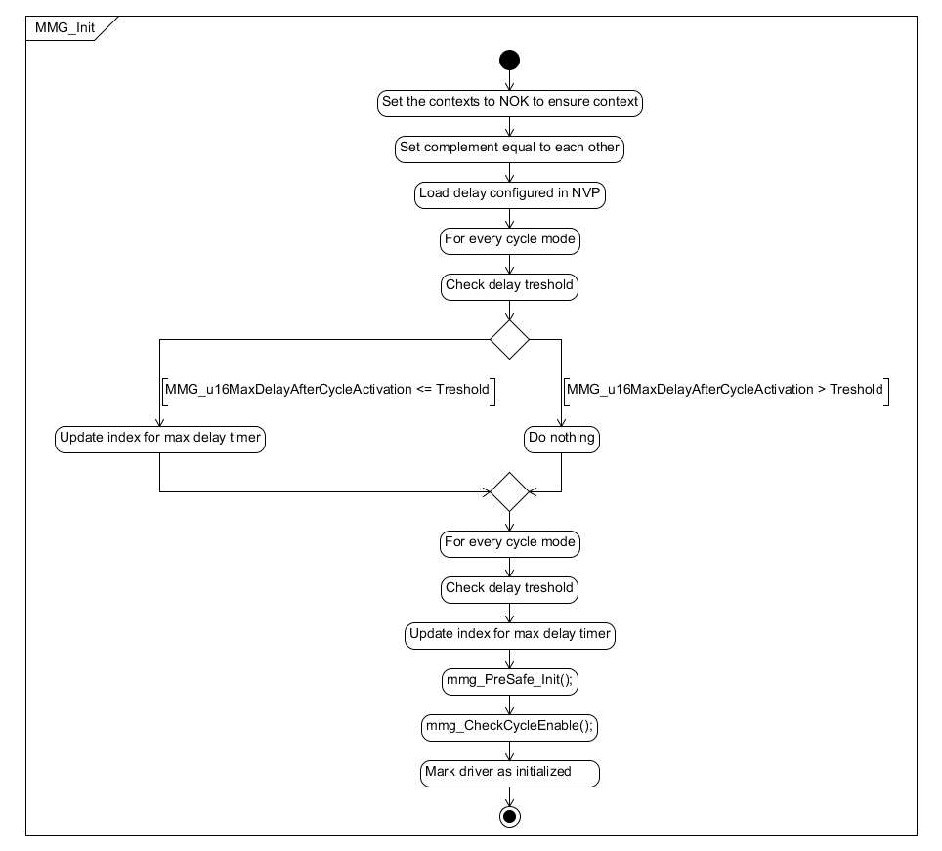

Figure : MMG_Init diagram

### MMG_runUpdateModeStatus

|  |  |  |
| --- | --- | --- |
| Object | | |
| This is the MMG main function that refreshes the status of every modes each time it is called. | | |
| **Prototype** | | |
| FUNC(void, MMG_AC_ModeManagement_CODE) MMG_runUpdateModeStatus(void) | | |
| **Input parameters** | | |
| Name | Type | Description |
| NA | NA | NA |
| **Output parameters** | | |
| Name | Type | Description |
| NA | NA | NA |
| **Return value** | | |
| Type | Description | |
| NA | void | |
| **Dynamic aspect** | | |
| Who(callers) | Description | |
| * | * | |
| **Static aspect** | | |
| NA | | |
| **Constrains** | | |
| NA | | |

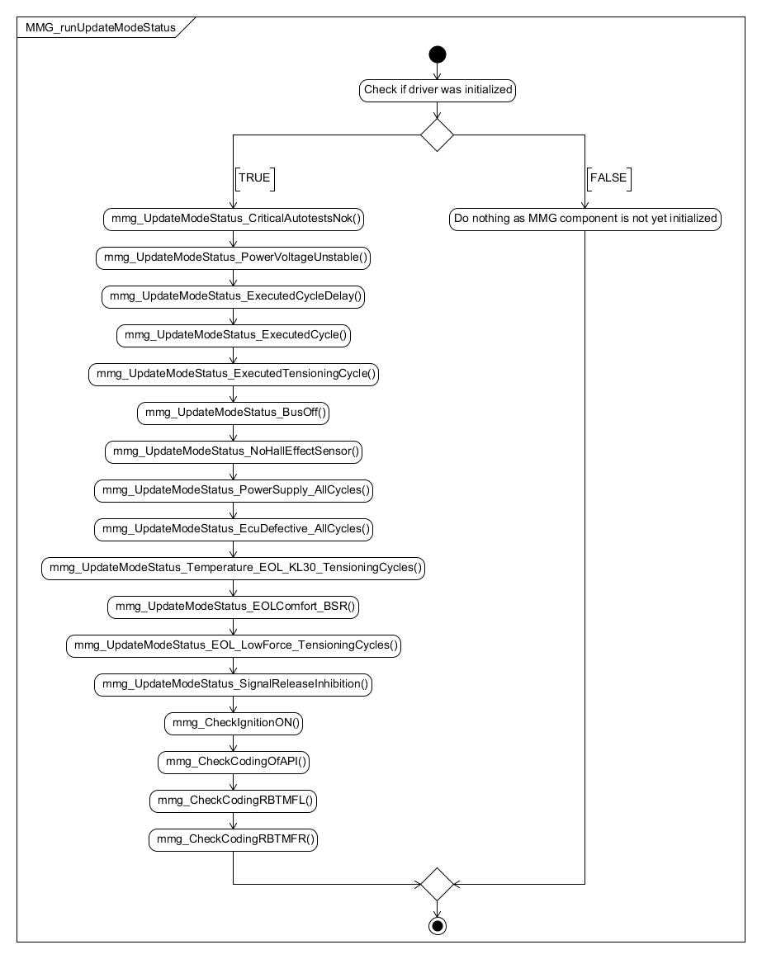

Figure : MMG_runUpdateModeStatus diagram

### MMG_runManageModeDelays

|  |  |  |
| --- | --- | --- |
| Object | | |
| This is the MMG function that handles all the timers needed by the MMG modes. | | |
| **Prototype** | | |
| FUNC(void, MMG_AC_ModeManagement_CODE) MMG_runManageModeDelays(void) | | |
| **Input parameters** | | |
| Name | Type | Description |
| NA | NA | NA |
| **Output parameters** | | |
| Name | Type | Description |
| NA | NA | NA |
| **Return value** | | |
| Type | Description | |
| NA | void | |
| **Dynamic aspect** | | |
| Who(callers) | Description | |
| * | * | |
| **Static aspect** | | |
| NA | | |
| **Constrains** | | |
| NA | | |

Figure : MMG_runManageModeDelays diagram

### MMG_runCheckModeStatus

|  |  |  |
| --- | --- | --- |
| Object | | |
| This is the mode checking service. It indicates whether all the required modes are activated. | | |
| **Prototype** | | |
| FUNC(void, MMG_AC_ModeManagement_CODE) MMG_runCheckModeStatus(u32ModeMaskType u32ModesToCheck, P2VAR(u8ModeStatusType, AUTOMATIC, RTE_MMG_AC_MODEMANAGEMENT_APPL_VAR) bModeStatus) | | |
| **Input parameters** | | |
| Name | Type | Description |
| u32ModesToCheck | u32ModeMaskType | Mask of the selected modes |
| **Output parameters** | | |
| Name | Type | Description |
| * bModeStatus | u8ModeStatusType | Status of the required selected modes |
| **Return value** | | |
| Type | Description | |
| NA | void | |
| **Dynamic aspect** | | |
| Who(callers) | Description | |
| Called by PAL, PRE, SFR, CIL | * | |
| **Static aspect** | | |
| NA | | |
| **Constrains** | | |
| NA | | |

Figure : MMG_runCheckModeStatus diagram

### mmg_UpdateModeStatus_CriticalAutotestsNok

|  |  |  |
| --- | --- | --- |
| Object | | |
| This is the executing mode function in charge of manages the “critical auto tests nok” mode. | | |
| **Prototype** | | |
| void mmg_UpdateModeStatus_CriticalAutotestsNok(void) | | |
| **Input parameters** | | |
| Name | Type | Description |
| NA | NA | NA |
| **Output parameters** | | |
| Name | Type | Description |
| NA | NA | NA |
| **Return value** | | |
| Type | Description | |
| NA | void | |
| **Dynamic aspect** | | |
| Who(callers) | Description | |
| MMG_runUpdateModeStatus | * | |
| **Static aspect** | | |
| NA | | |
| **Constrains** | | |
| NA | | |

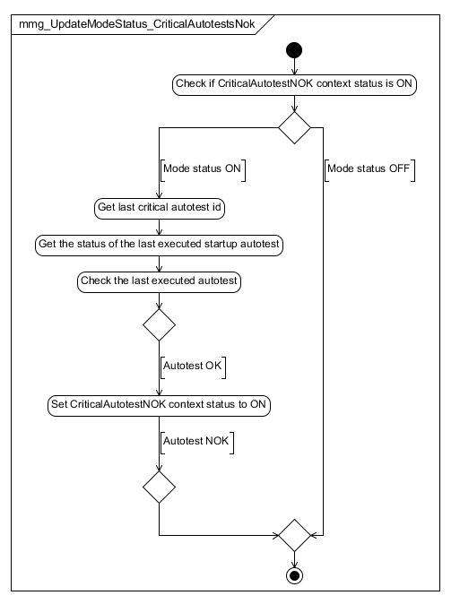

Figure : mmg_UpdateModeStatus_CriticalAutotestsNok diagram

### mmg_UpdateModeStatus_PowerVoltageUnstable

|  |  |  |
| --- | --- | --- |
| Object | | |
| This is the executing mode function in charge of manages the “power voltage unstable” mode. | | |
| **Prototype** | | |
| void mmg_UpdateModeStatus_PowerVoltageUnstable(void) | | |
| **Input parameters** | | |
| Name | Type | Description |
| NA | NA | NA |
| **Output parameters** | | |
| Name | Type | Description |
| NA | NA | NA |
| **Return value** | | |
| Type | Description | |
| NA | void | |
| **Dynamic aspect** | | |
| Who(callers) | Description | |
| MMG_runUpdateModeStatus | * | |
| **Static aspect** | | |
| NA | | |
| **Constrains** | | |
| NA | | |

Figure : mmg_UpdateModeStatus_PowerVoltageUnstable diagram

### mmg_UpdateModeStatus_ExecutedCycleDelay

|  |  |  |
| --- | --- | --- |
| Object | | |
| This is the executing mode function in charge of manages the “executed cycle with delay” modes. | | |
| **Prototype** | | |
| void mmg_UpdateModeStatus_ExecutedCycleDelay(void) | | |
| **Input parameters** | | |
| Name | Type | Description |
| NA | NA | NA |
| **Output parameters** | | |
| Name | Type | Description |
| NA | NA | NA |
| **Return value** | | |
| Type | Description | |
| NA | void | |
| **Dynamic aspect** | | |
| Who(callers) | Description | |
| MMG_runUpdateModeStatus | * | |
| **Static aspect** | | |
| NA | | |
| **Constrains** | | |
| NA | | |

Figure : mmg_UpdateModeStatus_ExecutedCycleDelay diagram

### mmg_UpdateModeStatus_ExecutedCycle

|  |  |  |
| --- | --- | --- |
| Object | | |
| This is the executing mode function in charge of manages the “executed cycle” mode. | | |
| **Prototype** | | |
| void mmg_UpdateModeStatus_ExecutedCycle(void) | | |
| **Input parameters** | | |
| Name | Type | Description |
| NA | NA | NA |
| **Output parameters** | | |
| Name | Type | Description |
| NA | NA | NA |
| **Return value** | | |
| Type | Description | |
| NA | void | |
| **Dynamic aspect** | | |
| Who(callers) | Description | |
| MMG_runUpdateModeStatus | * | |
| **Static aspect** | | |
| NA | | |
| **Constrains** | | |
| NA | | |

Figure : mmg_UpdateModeStatus_ExecutedCycle diagram

### mmg_UpdateModeStatus_ExecutedTensioningCycle

|  |  |  |
| --- | --- | --- |
| Object | | |
| This is the executing mode function in charge of manages the “executed tensioning cycle” mode. | | |
| **Prototype** | | |
| void mmg_UpdateModeStatus_ExecutedTensioningCycle(void) | | |
| **Input parameters** | | |
| Name | Type | Description |
| NA | NA | NA |
| **Output parameters** | | |
| Name | Type | Description |
| NA | NA | NA |
| **Return value** | | |
| Type | Description | |
| NA | void | |
| **Dynamic aspect** | | |
| Who(callers) | Description | |
| MMG_runUpdateModeStatus | * | |
| **Static aspect** | | |
| NA | | |
| **Constrains** | | |
| NA | | |

Figure : mmg_UpdateModeStatus_ExecutedTensioningCycle diagram

### mmg_UpdateModeStatus_BusOff

|  |  |  |
| --- | --- | --- |
| Object | | |
| This is the executing mode function in charge of manages the “bus off” mode. | | |
| **Prototype** | | |
| void mmg_UpdateModeStatus_BusOff(void) | | |
| **Input parameters** | | |
| Name | Type | Description |
| NA | NA | NA |
| **Output parameters** | | |
| Name | Type | Description |
| NA | NA | NA |
| **Return value** | | |
| Type | Description | |
| NA | void | |
| **Dynamic aspect** | | |
| Who(callers) | Description | |
| MMG_runUpdateModeStatus | * | |
| **Static aspect** | | |
| NA | | |
| **Constrains** | | |
| NA | | |

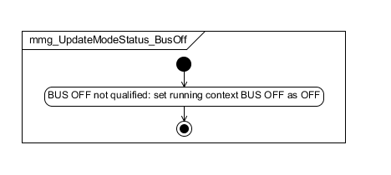

Figure : mmg_UpdateModeStatus_BusOff diagram

### mmg_UpdateModeStatus_NoHallEffectSensor

|  |  |  |
| --- | --- | --- |
| Object | | |
| This is the executing mode function in charge of manages the “no hall effect sensor” mode. | | |
| **Prototype** | | |
| void mmg_UpdateModeStatus_NoHallEffectSensor(void) | | |
| **Input parameters** | | |
| Name | Type | Description |
| NA | NA | NA |
| **Output parameters** | | |
| Name | Type | Description |
| NA | NA | NA |
| **Return value** | | |
| Type | Description | |
| NA | void | |
| **Dynamic aspect** | | |
| Who(callers) | Description | |
| MMG_runUpdateModeStatus | * | |
| **Static aspect** | | |
| NA | | |
| **Constrains** | | |
| NA | | |

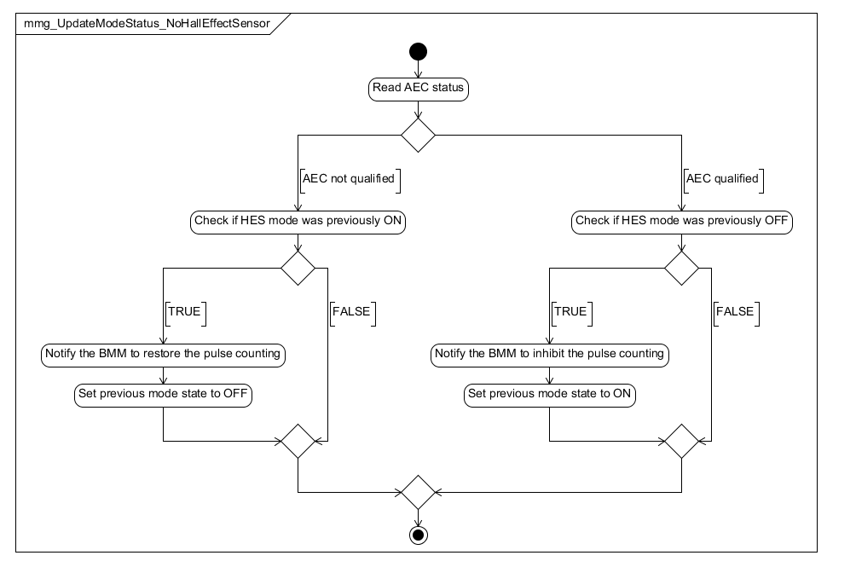

Figure mmg_UpdateModeStatus_ NoHallEffectSensor f diagram

### mmg_UpdateModeStatus_DefaultValues

|  |  |  |
| --- | --- | --- |
| Object | | |
| This is the executing mode function in charge of manages the “default values” mode. | | |
| **Prototype** | | |
| void mmg_UpdateModeStatus_DefaultValues(void) | | |
| **Input parameters** | | |
| Name | Type | Description |
| NA | NA | NA |
| **Output parameters** | | |
| Name | Type | Description |
| NA | NA | NA |
| **Return value** | | |
| Type | Description | |
| NA | void | |
| **Dynamic aspect** | | |
| Who(callers) | Description | |
| MMG_runUpdateModeStatus | * | |
| **Static aspect** | | |
| NA | | |
| **Constrains** | | |
| NA | | |

Figure mmg_UpdateModeStatus_DefaultValues diagram

### mmg_UpdateModeStatus_PowerSupply_AllCycles

|  |  |  |
| --- | --- | --- |
| Object | | |
| This is the executing mode function in charge of manages the inhibition of all cycles by Power supply | | |
| **Prototype** | | |
| void mmg_UpdateModeStatus_PowerSupply_AllCycles(void) | | |
| **Input parameters** | | |
| Name | Type | Description |
| NA | NA | NA |
| **Output parameters** | | |
| Name | Type | Description |
| NA | NA | NA |
| **Return value** | | |
| Type | Description | |
| NA | void | |
| **Dynamic aspect** | | |
| Who(callers) | Description | |
| MMG_runUpdateModeStatus | * | |
| **Static aspect** | | |
| NA | | |
| **Constrains** | | |
| NA | | |



Figure mmg_UpdateModeStatus_PowerSupply_AllCycles:

### mmg_UpdateModeStatus_EcuDefective_AllCycles

|  |  |  |
| --- | --- | --- |
| Object | | |
| This is the executing mode function in charge of manages the inhibition of all cycles by ECU defective | | |
| **Prototype** | | |
| void mmg_UpdateModeStatus_EcuDefective_AllCycles(void) | | |
| **Input parameters** | | |
| Name | Type | Description |
| NA | NA | NA |
| **Output parameters** | | |
| Name | Type | Description |
| NA | NA | NA |
| **Return value** | | |
| Type | Description | |
| NA | void | |
| **Dynamic aspect** | | |
| Who(callers) | Description | |
| MMG_runUpdateModeStatus | * | |
| **Static aspect** | | |
| NA | | |
| **Constrains** | | |
| NA | | |



Figure mmg_UpdateModeStatus_EcuDefective_AllCycles

### mmg_UpdateModeStatus_EOLComfort_BSR

|  |  |  |
| --- | --- | --- |
| Object | | |
| This is the executing mode function in charge of manages the inhibition of BSR by EOL Comfort | | |
| **Prototype** | | |
| void mmg_UpdateModeStatus_EOLComfort_BSR(void) | | |
| **Input parameters** | | |
| Name | Type | Description |
| NA | NA | NA |
| **Output parameters** | | |
| Name | Type | Description |
| NA | NA | NA |
| **Return value** | | |
| Type | Description | |
| NA | void | |
| **Dynamic aspect** | | |
| Who(callers) | Description | |
| MMG_runUpdateModeStatus | * | |
| **Static aspect** | | |
| NA | | |
| **Constrains** | | |
| NA | | |



Figure mmg_UpdateModeStatus_EOLComfort_BSR

### mmg_UpdateModeStatus_ EOL_LowForce_TensioningCycles

|  |  |  |
| --- | --- | --- |
| Object | | |
| This is the executing mode function in charge of manages the inhibition of tensioning cycles by : LOW Force Counter | | |
| **Prototype** | | |
| void mmg_UpdateModeStatus EOL_LowForce_TensioningCycles (void) | | |
| **Input parameters** | | |
| Name | Type | Description |
| NA | NA | NA |
| **Output parameters** | | |
| Name | Type | Description |
| NA | NA | NA |
| **Return value** | | |
| Type | Description | |
| NA | void | |
| **Dynamic aspect** | | |
| Who(callers) | Description | |
| MMG_runUpdateModeStatus | * | |
| **Static aspect** | | |
| NA | | |

Figure : mmg_UpdateModeStatus_ EOL_LowForce_TensioningCycles

### mmg_UpdateModeStatus_Temperature_EOL_KL30_TensioningCycles

|  |  |  |
| --- | --- | --- |
| Object | | |
| This is the executing mode function in charge of manages the inhibition of tensioning cycles by : Temperature high ,KL30 OV and UV. | | |
| **Prototype** | | |
| void mmg_UpdateModeStatus_Temperature_EOL_KL30_TensioningCycles(void) | | |
| **Input parameters** | | |
| Name | Type | Description |
| NA | NA | NA |
| **Output parameters** | | |
| Name | Type | Description |
| NA | NA | NA |
| **Return value** | | |
| Type | Description | |
| NA | void | |
| **Dynamic aspect** | | |
| Who(callers) | Description | |
| MMG_runUpdateModeStatus | * | |
| **Static aspect** | | |
| NA | | |



Figure : mmg_UpdateModeStatus_Temperature_EOL_KL30_TensioningCycles

### mmg_ManageModeDelays_ExecutedCycle

|  |  |  |
| --- | --- | --- |
| Object | | |
| This is the function in charge of managing the timers for the Executed Cycle modes. | | |
| **Prototype** | | |
| void mmg_ManageModeDelays_ExecutedCycle(void) | | |
| **Input parameters** | | |
| Name | Type | Description |
| NA | NA | NA |
| **Output parameters** | | |
| Name | Type | Description |
| NA | NA | NA |
| **Return value** | | |
| Type | Description | |
| NA | void | |
| **Dynamic aspect** | | |
| Who(callers) | Description | |
| MMG_runManageModeDelays | * | |
| **Static aspect** | | |
| NA | | |
| **Constrains** | | |
| NA | | |

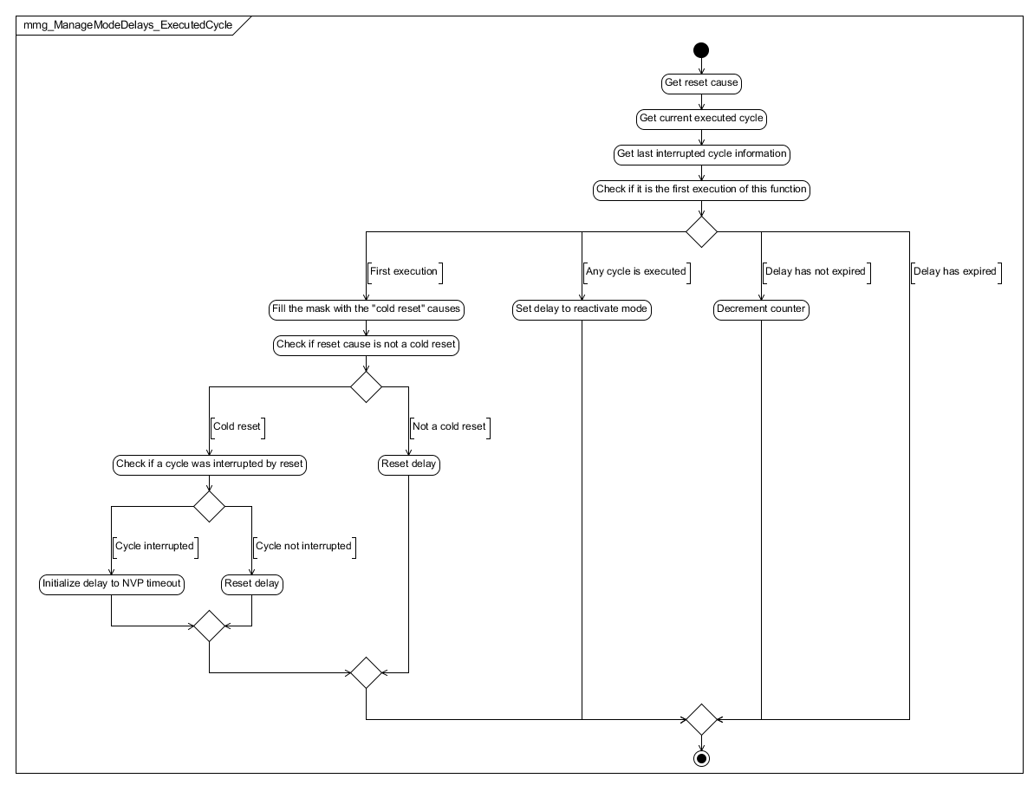

Figure : mmg_ManageModeDelays_ExecutedCycle diagram

### mmg_CheckIfCycleStepIsvalid

|  |  |  |
| --- | --- | --- |
| Object | | |
| This function is in charge of verifying if cycle has valid steps. | | |
| **Prototype** | | |
| LOCAL boolean mmg_CheckIfCycleStepIsvalid(const uint16 u16Step0) | | |
| **Input parameters** | | |
| Name | Type | Description |
| u16Step0 | uint16 | Step0 from cycle that will be verified |
| **Output parameters** | | |
| Name | Type | Description |
| NA | NA | NA |
| **Return value** | | |
| Type | Description | |
| boolean b8Ret | Function return if a cycle is valid or not. | |
| **Dynamic aspect** | | |
| Who(callers) | Description | |
| mmg_CheckCycleEnable | * | |
| **Static aspect** | | |
| NA | | |
| **Constrains** | | |
| NA | | |



Figure : mmg_CheckIfCycleStepIsvalid diagram

### mmg_CheckCycleEnable

|  |  |  |
| --- | --- | --- |
| Object | | |
| This is the executing mode function in charge of manages the “bus off” mode. | | |
| **Prototype** | | |
| LOCAL void mmg_CheckCycleEnable(void) | | |
| **Input parameters** | | |
| Name | Type | Description |
| NA | NA | NA |
| **Output parameters** | | |
| Name | Type | Description |
| NA | NA | NA |
| **Return value** | | |
| Type | Description | |
| NA | void | |
| **Dynamic aspect** | | |
| Who(callers) | Description | |
| MMG_Init | * | |
| **Static aspect** | | |
| NA | | |
| **Constrains** | | |
| NA | | |



Figure : mmg_CheckCycleEnable diagram

### mmg_PreSafe_CopyStartData

|  |  |  |
| --- | --- | --- |
| Object | | |
| Function is in charge of copying start data to RAM structure | | |
| **Prototype** | | |
| LOCAL void mmg_PreSafe_CopyStartData(void) | | |
| **Input parameters** | | |
| Name | Type | Description |
| NA | NA | NA |
| **Output parameters** | | |
| Name | Type | Description |
| NA | NA | NA |
| **Return value** | | |
| Type | Description | |
| NA | void | |
| **Dynamic aspect** | | |
| Who(callers) | Description | |
| mmg_PreSafe_HandleStartData | * | |
| **Static aspect** | | |
| NA | | |
| **Constrains** | | |
| NA | | |

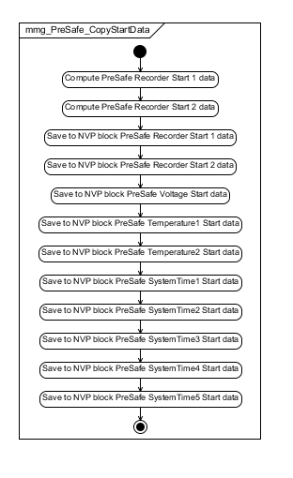

Figure : mmg_PreSafe_CopyStartData

### mmg_PreSafe_CopyStopData

|  |  |  |
| --- | --- | --- |
| Object | | |
| Function is in charge of copying stop data to RAM structure | | |
| **Prototype** | | |
| LOCAL void mmg_PreSafe_CopyStopData(void) | | |
| **Input parameters** | | |
| Name | Type | Description |
| NA | NA | NA |
| **Output parameters** | | |
| Name | Type | Description |
| NA | NA | NA |
| **Return value** | | |
| Type | Description | |
| NA | void | |
| **Dynamic aspect** | | |
| Who(callers) | Description | |
| mmg_PreSafe_HandleStopData | * | |
| **Static aspect** | | |
| NA | | |
| **Constrains** | | |
| NA | | |

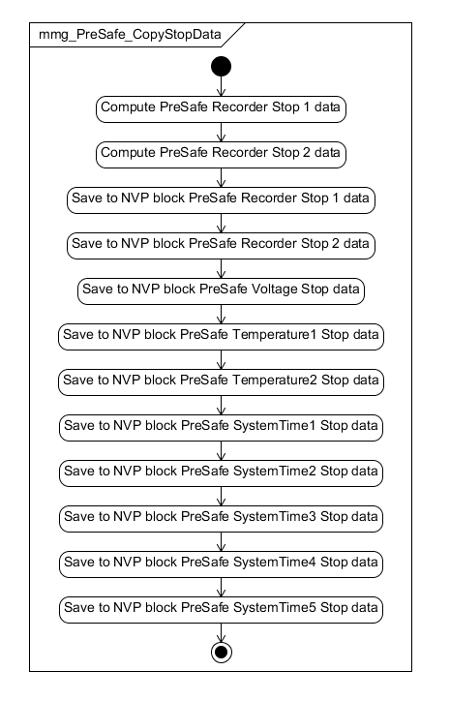

Figure : mmg_PreSafe_CopyStopData

### mmg_PreSafe_CopyStateData

|  |  |  |
| --- | --- | --- |
| Object | | |
| Function is in charge of copying state data to RAM structure | | |
| **Prototype** | | |
| LOCAL void mmg_PreSafe_CopyStateData(void) | | |
| **Input parameters** | | |
| Name | Type | Description |
| NA | NA | NA |
| **Output parameters** | | |
| Name | Type | Description |
| NA | NA | NA |
| **Return value** | | |
| Type | Description | |
| NA | void | |
| **Dynamic aspect** | | |
| Who(callers) | Description | |
| mmg_PreSafe_HandleStateData | * | |
| **Static aspect** | | |
| NA | | |
| **Constrains** | | |
| NA | | |

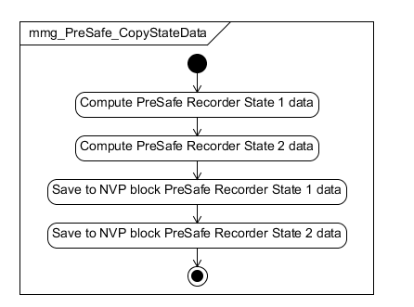

Figure : mmg_PreSafe_CopyStateData

### mmg_PreSafe_HandleStateData

|  |  |  |
| --- | --- | --- |
| Object | | |
| Function is in charge of handling input data and complete the raw state data to local structure | | |
| **Prototype** | | |
| LOCAL void mmg_PreSafe_HandleStateData(void) | | |
| **Input parameters** | | |
| Name | Type | Description |
| NA | NA | NA |
| **Output parameters** | | |
| Name | Type | Description |
| NA | NA | NA |
| **Return value** | | |
| Type | Description | |
| NA | void | |
| **Dynamic aspect** | | |
| Who(callers) | Description | |
| MMG_runPreSafeRecorder | * | |
| **Static aspect** | | |
| NA | | |
| **Constrains** | | |
| NA | | |

Note: Because of the size of the function, the diagram was splitted in two pictures.



Figure : Part1 mmg_PreSafe_HandleStateData



Figure : Part2 mmg_PreSafe_HandleStateData

### mmg_PreSafe_HandleStartData

|  |  |  |
| --- | --- | --- |
| Object | | |
| Function is in charge of handling input data and complete the raw start data to local structure | | |
| **Prototype** | | |
| LOCAL void mmg_PreSafe_HandleStartData(void) | | |
| **Input parameters** | | |
| Name | Type | Description |
| NA | NA | NA |
| **Output parameters** | | |
| Name | Type | Description |
| NA | NA | NA |
| **Return value** | | |
| Type | Description | |
| NA | void | |
| **Dynamic aspect** | | |
| Who(callers) | Description | |
| MMG_runPreSafeRecorder | * | |
| **Static aspect** | | |
| NA | | |
| **Constrains** | | |
| NA | | |

Note: Because of the size of the function, the diagram was splitted in two pictures.



Figure : Part1 mmg_PreSafe_HandleStartData



Figure : Part2 mmg_PreSafe_HandleStartData

### mmg_PreSafe_HandleStopData

|  |  |  |
| --- | --- | --- |
| Object | | |
| Function is in charge of handling input data and complete the raw stop data to local structure | | |
| **Prototype** | | |
| LOCAL void mmg_PreSafe_HandleStopData(void) | | |
| **Input parameters** | | |
| Name | Type | Description |
| NA | NA | NA |
| **Output parameters** | | |
| Name | Type | Description |
| NA | NA | NA |
| **Return value** | | |
| Type | Description | |
| NA | void | |
| **Dynamic aspect** | | |
| Who(callers) | Description | |
| MMG_runPreSafeRecorder | * | |
| **Static aspect** | | |
| NA | | |
| **Constrains** | | |
| NA | | |

Note: Because of the size of the function, the diagram was splitted in two pictures.



Figure : Part1 mmg_PreSafe_HandleStopData



Figure : Part1 mmg_PreSafe_HandleStopData

### mmg_PreSafe_Init

|  |  |  |
| --- | --- | --- |
| Object | | |
| Function is in charge of initializing the PreSafe structures | | |
| **Prototype** | | |
| FUNC(void, MMG_AC_ModeManagement_CODE) mmg_PreSafe_Init(void) | | |
| **Input parameters** | | |
| Name | Type | Description |
| NA | NA | NA |
| **Output parameters** | | |
| Name | Type | Description |
| NA | NA | NA |
| **Return value** | | |
| Type | Description | |
| NA | void | |
| **Dynamic aspect** | | |
| Who(callers) | Description | |
| MMG_Init | * | |
| **Static aspect** | | |
| NA | | |
| **Constrains** | | |
| NA | | |

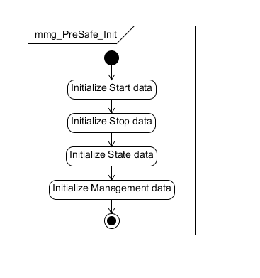

Figure : mmg_PreSafe_Init

### MMG_runPreSafeRecorder

|  |  |  |
| --- | --- | --- |
| Object | | |
| Function is in charge handling the mode management of Presafe recorder | | |
| **Prototype** | | |
| FUNC(void, MMG_AC_ModeManagement_CODE) MMG_runPreSafeRecorder(void) | | |
| **Input parameters** | | |
| Name | Type | Description |
| NA | NA | NA |
| **Output parameters** | | |
| Name | Type | Description |
| NA | NA | NA |
| **Return value** | | |
| Type | Description | |
| NA | void | |
| **Dynamic aspect** | | |
| Who(callers) | Description | |
| Every 10 ms | * | |
| **Static aspect** | | |
| NA | | |
| **Constrains** | | |
| NA | | |

Note: Because of the size of the function, the diagram was splitted in three pictures.



Figure : Part1 MMG_runPreSafeRecorder



Figure : Part2 MMG_runPreSafeRecorder



Figure : Part3 MMG_runPreSafeRecorder

### mmg_PreSafe_CheckEOLLimit

|  |  |  |
| --- | --- | --- |
| Object | | |
| Function is in charge of checking EOL counter inhibition status | | |
| **Prototype** | | |
| LOCAL void mmg_PreSafe_CheckEOLLimit(void) | | |
| **Input parameters** | | |
| Name | Type | Description |
| NA | NA | NA |
| **Output parameters** | | |
| Name | Type | Description |
| NA | NA | NA |
| **Return value** | | |
| Type | Description | |
| NA | void | |
| **Dynamic aspect** | | |
| Who(callers) | Description | |
|  | * | |
| **Static aspect** | | |
| NA | | |
| **Constrains** | | |
| NA | | |



Figure : mmg_PreSafe_CheckEOLLimit

### mmg_AvailabilityDataStatus

|  |  |  |
| --- | --- | --- |
| Object | | |
| Function is in charge to handle the AvailabilityDataStatus and route it to DiagFunction | | |
| **Prototype** | | |
| void mmg_AvailabilityDataStatus(void) | | |
| **Input parameters** | | |
| Name | Type | Description |
| NA | NA | NA |
| **Output parameters** | | |
| Name | Type | Description |
| NA | NA | NA |
| **Return value** | | |
| Type | Description | |
| NA | void | |
| **Dynamic aspect** | | |
| Who(callers) | Description | |
| MMG_runUpdateModeStatus | * | |
| **Static aspect** | | |
| NA | | |
| **Constrains** | | |
| NA | | |

Figure : mmg_AvailabilityDataStatus

### mmg_UpdateModeStatus_SignalReleaseInhibition

|  |  |  |  |
| --- | --- | --- | --- |
| Object | | | |
| This is the executing mode function in charge of inhibitiing release profile by customer signals. | | | |
| **Prototype** | | | |
| void mmg_UpdateModeStatus_SignalReleaseInhibition (void) | | | |
| **Parameters** | | | |
| void | | | |
| **Exceptions** | | | |
| None | | | |
| **Precondition** | | | |
| None | | | |
| **Postcondition** | | | |
| None | | | |
| **Input parameters** | | | |
| Name | Type | Description | Range |
| NA | NA | NA | NA |
| **Output parameters** | | | |
| Name | Type | Description | Range |
| NA | NA | NA | NA |
| **Return value** | | | |
| Type | Description | | |
| NA | void | | |
| **Dynamic aspect** | | | |
| Who(callers) | Description | | |
| * | * | | |
| **Static aspect** | | | |
| * | | | |
| **Constrains** | | | |
|  | | | |



Figure mmg_UpdateModeStatus_SignalReleaseInhibition

### MMG_runUpdateNVMBlocks

|  |  |  |  |
| --- | --- | --- | --- |
| Object | | | |
| The function checks if a specific NVM block needs written and send a request write for the specific block | | | |
| **Prototype** | | | |
| FUNC(void, MMG_AC_ModeManagement_CODE) MMG_runUpdateNVMBlocks(void) | | | |
| **Parameters** | | | |
| void | | | |
| **Exceptions** | | | |
| None | | | |
| **Precondition** | | | |
| None | | | |
| **Postcondition** | | | |
| None | | | |
| **Input parameters** | | | |
| Name | Type | Description | Range |
| NA | NA | NA | NA |
| **Output parameters** | | | |
| Name | Type | Description | Range |
| NA | NA | NA | NA |
| **Return value** | | | |
| Type | Description | | |
| NA | void | | |
| **Dynamic aspect** | | | |
| Who(callers) | Description | | |
| * | * | | |
| **Static aspect** | | | |
| * | | | |
| **Constrains** | | | |
|  | | | |



Figure MMG_runUpdateNVMBlocks

### mmg_CheckCodingOfAPI

|  |  |  |  |
| --- | --- | --- | --- |
| Object | | | |
| The function is called to mange CodingOfAPI enable condition context. | | | |
| **Prototype** | | | |
| void mmg_CheckCodingOfAPI (void) | | | |
| **Parameters** | | | |
| void | | | |
| **Exceptions** | | | |
| None | | | |
| **Precondition** | | | |
| None | | | |
| **Postcondition** | | | |
| None | | | |
| **Input parameters** | | | |
| Name | Type | Description | Range |
| NA | NA | NA | NA |
| **Output parameters** | | | |
| Name | Type | Description | Range |
| NA | NA | NA | NA |
| **Return value** | | | |
| Type | Description | | |
| NA | void | | |
| **Dynamic aspect** | | | |
| Who(callers) | Description | | |
| * | * | | |
| **Static aspect** | | | |
| * | | | |
| **Constrains** | | | |
|  | | | |



Figure Check coding of API

### mmg_CheckCodingRBTMFL

|  |  |  |  |
| --- | --- | --- | --- |
| Object | | | |
| The function is called to mange CodingRBTMFL enable condition context. | | | |
| **Prototype** | | | |
| void mmg_CheckCodingRBTMFL (void) | | | |
| **Parameters** | | | |
| void | | | |
| **Exceptions** | | | |
| None | | | |
| **Precondition** | | | |
| None | | | |
| **Postcondition** | | | |
| None | | | |
| **Input parameters** | | | |
| Name | Type | Description | Range |
| NA | NA | NA | NA |
| **Output parameters** | | | |
| Name | Type | Description | Range |
| NA | NA | NA | NA |
| **Return value** | | | |
| Type | Description | | |
| NA | void | | |
| **Dynamic aspect** | | | |
| Who(callers) | Description | | |
| * | * | | |
| **Static aspect** | | | |
| * | | | |
| **Constrains** | | | |
|  | | | |



Figure Check coding of RBTMFL

### mmg_CheckCodingRBTMFR

|  |  |  |  |
| --- | --- | --- | --- |
| Object | | | |
| The function is called to mange CodingRBTMFR enable condition context. | | | |
| **Prototype** | | | |
| void mmg_CheckCodingRBTMFR (void) | | | |
| **Parameters** | | | |
| void | | | |
| **Exceptions** | | | |
| None | | | |
| **Precondition** | | | |
| None | | | |
| **Postcondition** | | | |
| None | | | |
| **Input parameters** | | | |
| Name | Type | Description | Range |
| NA | NA | NA | NA |
| **Output parameters** | | | |
| Name | Type | Description | Range |
| NA | NA | NA | NA |
| **Return value** | | | |
| Type | Description | | |
| NA | void | | |
| **Dynamic aspect** | | | |
| Who(callers) | Description | | |
| * | * | | |
| **Static aspect** | | | |
| * | | | |
| **Constrains** | | | |
|  | | | |



Figure Check coding of RBTMFR

### mmg_CheckIgnitionON

|  |  |  |  |
| --- | --- | --- | --- |
| Object | | | |
| The function is called to mange IgnitionON enable condition context. | | | |
| **Prototype** | | | |
| void mmg_CheckIgnitionON (void) | | | |
| **Parameters** | | | |
| void | | | |
| **Exceptions** | | | |
| None | | | |
| **Precondition** | | | |
| None | | | |
| **Postcondition** | | | |
| None | | | |
| **Input parameters** | | | |
| Name | Type | Description | Range |
| NA | NA | NA | NA |
| **Output parameters** | | | |
| Name | Type | Description | Range |
| NA | NA | NA | NA |
| **Return value** | | | |
| Type | Description | | |
| NA | void | | |
| **Dynamic aspect** | | | |
| Who(callers) | Description | | |
| * | * | | |
| **Static aspect** | | | |
| * | | | |
| **Constrains** | | | |
|  | | | |



Figure Check Ignition status

## Types

### MMG_stModeDelayType

|  |  |  |
| --- | --- | --- |
| **Field Name** | **Field Type** | **Field description** |
| u16DelayThrs | uint16 | Holds the value of delay to wait after cycle activation |
| u32AssociatedMode | uint32 | Holds the mask of the associated MMG mode |

### MMG_stModeConfigurationType

|  |  |  |
| --- | --- | --- |
| **Field Name** | **Field Type** | **Field description** |
| pfModeCallback | tSystemContextCallbackFct | Pointer to function callback |

### MMG_KU8_IDX

|  |  |  |
| --- | --- | --- |
| **Field Name** | **Field Type** | **Field description** |
| MMG_KU8_IDX_HWSELFPROT | enumeration type (0) | Index for HW Self Protection Autotest |
| MMG_KU8_IDX_MOTORCURRENT | enumeration type (1) | Index for Motor Current Autotest |
| MMG_KU8_IDX_MOTORTEMP | enumeration type (2) | Index for Motor Thermal Protection Autotest |
| MMG_KU8_IDX_UNDERVOLTAGE | enumeration type (3) | Index for Undervoltage Autotest |
| MMG_KU8_IDX_OVERVOLTAGE | enumeration type (4) | Index for Overvoltage Autotest |
| MMG_KU8_IDX_UNDERVOLTAGE_TENS | enumeration type (5) | Index for Undervoltage During Activation Autotest |
| MMG_KU8_IDX_OVERVOLTAGE_TENS | enumeration type (6) | Index for Overvoltage During Activation Autotest |
| MMG_KU8_NR_OF_AUTOTESTS | enumeration type (7) | Total number of autotests used |

### mmg_stPreSafeRecorderStartData

|  |  |  |
| --- | --- | --- |
| **Field Name** | **Field Type** | **Field description** |
| Start1BuckleSwitch | uint8 : 2 | To store the Start1 Buckle Switch |
| Start1BeltHandOver | uint8 : 2 | To store the Start1 Belt Hand Over |
| Start2PreSafeLvl | uint8 : 3 | To store the Start2 PreSafe Lvl |
| Start2ImpactX | uint8 : 1 | To store the Start2 ImpactX |
| Start2RollOverType1 | uint8 : 1 | To store the Start2 RollOverType1 |
| Start2RollOverType2 | uint8 : 1 | To store the Start2 RollOverType2 |
| StartVoltage | uint8 : 8 | To store the Start Voltage |
| StartTemperature1 | uint8 : 8 | To store the Start Temperature1 |
| StartTemperature2 | uint8 : 8 | To store the Start Temperature2 |
| StartSystemTime1 | uint8 : 8 | To store the Start SystemTime1 |
| StartSystemTime2 | uint8 : 8 | To store the Start SystemTime2 |
| StartSystemTime3 | uint8 : 8 | To store the Start SystemTime3 |
| StartSystemTime4 | uint8 : 8 | To store the Start SystemTime4 |
| StartSystemTime5 | uint8 : 8 | To store the Start SystemTime5 |

### mmg_stPreSafeRecorderStopData

|  |  |  |
| --- | --- | --- |
| **Field Name** | **Field Type** | **Field description** |
| Stop1BuckleSwitch | uint8 : 2 | To store the Stop1 Buckle Switch |
| Stop1BeltHandOver | uint8 : 2 | To store the Stop1 Belt Hand Over |
| Stop2PreSafeLvl | uint8 : 3 | To store the Stop2 PreSafe Lvl |
| Stop2ImpactX | uint8 : 1 | To store the Stop2 ImpactX |
| Stop2RollOverType1 | uint8 : 1 | To store the Stop2 RollOverType1 |
| Stop2RollOverType2 | uint8 : 1 | To store the Stop2 RollOverType2 |
| StopVoltage | uint8 : 8 | To store the Stop Voltage |
| StopTemperature1 | uint8 : 8 | To store the Stop Temperature1 |
| StopTemperature2 | uint8 : 8 | To store the Stop Temperature2 |
| StopSystemTime1 | uint8 : 8 | To store the Stop SystemTime1 |
| StopSystemTime2 | uint8 : 8 | To store the Stop SystemTime2 |
| StopSystemTime3 | uint8 : 8 | To store the Stop SystemTime3 |
| StopSystemTime4 | uint8 : 8 | To store the Stop SystemTime4 |
| StopSystemTime5 | uint8 : 8 | To store the Stop SystemTime5 |

### mmg_stPreSafeRecorderStateData

|  |  |  |
| --- | --- | --- |
| **Field Name** | **Field Type** | **Field description** |
| State1TensioningState | uint8 : 2 | To store the State1 Tensioning State |
| State1PreSafeDisabled | uint8 : 1 | To store the State1 PreSafe disabled |
| State1PreSafeSupp | uint8 : 1 | To store the State1 PreSafe suppresion |
| State1PreSafeAbort | uint8 : 1 | To store the State1 PreSafe abortion |
| State1KL15 | uint8 : 1 | To store the State1 KL15 |
| State1UvOROV | uint8 : 1 | To store the State1 Overvoltage or Undervoltahe |
| State2OverTemp | uint8 : 1 | To store the State2 Overtemperature |
| State2PreSafeCounter | uint8 : 1 | To store the State2 EOL PreSafe Counter |
| State2SystemFailure | uint8 : 1 | To store the State2 System/Component failure |

### mmg_ stPreSafeRecorderManagement

|  |  |  |
| --- | --- | --- |
| **Field Name** | **Field Type** | **Field description** |
| PreSafeState | uint8 | To store the PreSafe state |
| PreSafePreviousState | uint8 | To store the PreSafe previous state |
| PreSafeWriteTrigger | uint8 | To store the PreSafe write trigger |
| PreSafeBufferID | uint8 | To store the PreSafe ID to be written |
| StartedProfile | uint8 | To store the started profile |
| ProfileInterrupedStatus | uint8 | To store the status of a new profile interrupted |
| NewProfileExecuted | uint8 | To store the new profile interrupted |

## Variables

### mmg_b8MMGHAsBeenInitialized

|  |  |  |
| --- | --- | --- |
| Type | Value |  |
| Boolean | 0x55 | |
| **Description** | | |
| Variables is used to detect if MMG component has been initialized | | |
| **Definition** | | |
| static boolean MMG_b8MMGHAsBeenInitialized | | |

### MMG_u32ModesStatus

|  |  |  |
| --- | --- | --- |
| Type | Value |  |
| uint32 | N.A. | |
| **Description** | | |
| Variable is used to set a running context | | |
| **Definition** | | |
| uint32 MMG_u32ModesStatus | | |

### MMG_u32ModesStatusComplement

|  |  |  |
| --- | --- | --- |
| Type | Value |  |
| uint32 | N.A. | |
| **Description** | | |
| Variable is used for processing information when set a running context | | |
| **Definition** | | |
| uint32 MMG_u32ModesStatusComplement | | |

### mmg_u16DelayToClearModeAfterCycle

|  |  |  |
| --- | --- | --- |
| Type | Value |  |
| uint16 | 0xFFFF | |
| **Description** | | |
| Variable represents the counter used to manage timeout for "Executed cycle" mode | | |
| **Definition** | | |
| static uint16 MMG_u16DelayToClearModeAfterCycle | | |

### MMG_u16MaxDelayAfterCycleActivation

|  |  |  |
| --- | --- | --- |
| Type | Value |  |
| uint16 | 0x00 | |
| **Description** | | |
| Variable which will be loaded, during MMG_Init, with the maximal value of delays configured in NVP | | |
| **Definition** | | |
| uint16 MMG_u16MaxDelayAfterCycleActivation | | |

### MMG_astDelayAfterCycleThrsandModes

|  |  |  |
| --- | --- | --- |
| Type | Value |  |
| * stModeDelayType | N.A. | |
| **Description** | | |
| Vector variable that represents the table defining delays associated to cycle execution MMG modes | | |
| **Definition** | | |
| stModeDelayType MMG_astDelayAfterCycleThrsandModes[KU8_NUMBER_OF_MMG_CYCLES_MODES_DELAYS] | | |

### mmg_u8PrevHESModeStatus

|  |  |  |
| --- | --- | --- |
| Type | Value |  |
| uint8 | 0x85 | |
| **Description** | | |
| Variable that stores the previous status of Hall Effect Sensor mode | | |
| **Definition** | | |
| static uint8 MMG_u8PrevHESModeStatus | | |

### mmg_stPreSafeManagement

|  |  |  |
| --- | --- | --- |
| Type | Value |  |
| mmg_stPreSafeRecorderManagement | { KU8_FALSE, KU8_NO_CYCLE, KU8_NO_CYCLE, KU8_TENSIONING_NONE, KU8_TENSIONING_NONE, MMG_KU8_PRESF_TRIGGER_OFF, NVP_BLOCK_ID_PRE_SAFE_RECORDER_ID_RamBlockData.NVP_u8PreSafeRecorderID } | |
| **Description** | | |
| Variable that stores the PreSafe Recorder management data | | |
| **Definition** | | |
| static mmg_stPreSafeRecorderManagement mmg_stPreSafeManagement | | |

### mmg_stPreSafeStartData

|  |  |  |
| --- | --- | --- |
| Type | Value |  |
| mmg_stPreSafeRecorderStartData | {0x00, 0x00, 0x00, 0x00, 0x00, 0x00, 0x00, 0x00, 0x00, 0x00, 0x00, 0x00, 0x00, 0x00} | |
| **Description** | | |
| Variable that stores the PreSafe Recorder start block data | | |
| **Definition** | | |
| static mmg_stPreSafeRecorderStartData mmg_stPreSafeStartData | | |

### mmg_stPreSafeStopData

|  |  |  |
| --- | --- | --- |
| Type | Value |  |
| mmg_stPreSafeRecorderStopData | {0x00, 0x00, 0x00, 0x00, 0x00, 0x00, 0x00, 0x00, 0x00, 0x00, 0x00, 0x00, 0x00, 0x00} | |
| **Description** | | |
| Variable that stores the PreSafe Recorder stop block data | | |
| **Definition** | | |
| static mmg_stPreSafeRecorderStopData mmg_stPreSafeStopData | | |

### mmg_stPreSafeStateData

|  |  |  |
| --- | --- | --- |
| Type | Value |  |
| mmg_stPreSafeRecorderStateData | {0x00, 0x00, 0x00, 0x00, 0x00, 0x00, 0x00, 0x00, 0x00} | |
| **Description** | | |
| Variable that stores the PreSafe Recorder state block data | | |
| **Definition** | | |
| static mmg_stPreSafeRecorderStateData mmg_stPreSafeStateData | | |

### mmg_stPreSafeInputData

|  |  |  |
| --- | --- | --- |
| Type | Value |  |
| REC_PreSafeRecInputType | {KU8_TENSIONING_NONE,I_C02_BCKL_SW_STAT_SNA,I_C04_PRESF_LVL_V2_NOLVL,KU8_ZERO,I_C03_NO_LT_RT_BOTH_NO,KU8_ZERO,KU8_ZERO,I_C03_ISW_STAT_IGN_LOCK, I_C02_BELTHDOVR_STAT_SNA} | |
| **Description** | | |
| Variable that stores the Pre Safe input data received from CIL module | | |
| **Definition** | | |
| static REC_PreSafeRecInputType mmg_stPreSafeInputData | | |

### mmg_u32DeficiencyLevel

|  |  |  |
| --- | --- | --- |
| Type | Value |  |
| u32DeficiencyLevelType | 0x00 | |
| **Description** | | |
| Variable that stores the deficiency level | | |
| **Definition** | | |
| static u32DeficiencyLevelType mmg_u32DeficiencyLevel | | |

### mmg_u16LocalVoltage

|  |  |  |
| --- | --- | --- |
| Type | Value |  |
| u16VoltageType | 0x00 | |
| **Description** | | |
| Variable that stores the Local voltage received from PMP module | | |
| **Definition** | | |
| static u16VoltageType mmg_u16LocalVoltage | | |

### mmg_TimeStamp

|  |  |  |
| --- | --- | --- |
| Type | Value |  |
| StbM_TimeStampType | {0x00, 0x00, 0x00, 0x00} | |
| **Description** | | |
| Variable that stores the time stampe data | | |
| **Definition** | | |
| static StbM_TimeStampType mmg_TimeStamp | | |

### mmg_TimeUserData

|  |  |  |
| --- | --- | --- |
| Type | Value |  |
| StbM_UserDataType | {0x00, 0x00, 0x00, 0x00} | |
| **Description** | | |
| Variable that stores the user time stampe data | | |
| **Definition** | | |
| static StbM_UserDataType mmg_TimeUserData | | |

### mmg_u8Return

|  |  |  |
| --- | --- | --- |
| Type | Value |  |
| Std_ReturnType | 0x01 | |
| **Description** | | |
| Variable that stores return value for time stampe RTE call | | |
| **Definition** | | |
| static Std_ReturnType mmg_u8Return | | |

### u8oldAvailabilityDataCategory

|  |  |  |
| --- | --- | --- |
| Type | Value |  |
| Uint8 | MMG_STATUS_IS_DEFAULT (0x01) | |
| **Description** | | |
| Variable that stores initial value of MMG status for the Availability Data Calculations | | |
| **Definition** | | |
| static uint8 u8oldAvailabilityDataCategory | | |

### MMG_u16EnableCondition_Status

|  |  |  |
| --- | --- | --- |
| Type | Value |  |
| uint8 | KU8_ZERO | |
| **Description** | | |
| This variable holds the status of the profile inhibition causes. | | |
| **Definition** | | |
| uint8 MMG_u16EnableCondition_Status = KU8_ZERO | | |
| **Remarks** | | |
| None. | | |

## Macros

### MMG_KU8_CYCLE_MODE_DELAY_INDEX

|  |  |
| --- | --- |
| Name | Value |
| Cycle Mode Delay Index | 0 |
| **Definition** | |
| #define MMG_KU8_CYCLE_MODE_DELAY_INDEX | |
| **Description** | |
| indicates the index value corresponding to the MMG cycle modes which needs delay in table astDelayAfterCycleThrsandModes | |

### MMG_KU8_CYCLE_MODE_DELAY_UV_INDEX

|  |  |
| --- | --- |
| Name | Value |
| Cycle Mode Delay UV Index | 1 |
| **Definition** | |
| #define MMG_KU8_CYCLE_MODE_DELAY_UV_INDEX | |
| **Description** | |
| indicates the index value corresponding to the MMG cycle modes which needs delay in table astDelayAfterCycleThrsandModes | |

### MMG_KU8_NUMBER_OF_CYCLES_MODES_DELAYS

|  |  |
| --- | --- |
| Name | Value |
| Number of cycle mode delays | 2 |
| **Definition** | |
| #define MMG_KU8_NUMBER_OF_CYCLES_MODES_DELAYS | |
| **Description** | |
| indicates the index value corresponding to the MMG cycle modes which needs delay in table astDelayAfterCycleThrsandModes | |

### MMG_U32_INITIAL_VALUES_FOR_ALL_MODES

|  |  |
| --- | --- |
| Name | Value |
| Initial value for all modes | (MMG_KU32_MASK_CRITICAL_AT_NOK |MMG_KU32_MASK_AEC_INHIB_ALL_CYCLES  | MMG_KU32_MASK_AEC_INHIB_TENSIONING_CYCLES) |
| **Definition** | |
| #define MMG_U32_INITIAL_VALUES_FOR_ALL_MODES | |
| **Description** | |
| This constant is used to initialize the modes | |

### MMG_KU8_CFG_LAST_PRE_TENSIONING_CYCLE

|  |  |
| --- | --- |
| Name | Value |
| Last Pre-Tensioning Cycle | KU8_BELT_FUNCTION_17 |
| **Definition** | |
| #define MMG_KU8_CFG_LAST_PRE_TENSIONING_CYCLE | |
| **Description** | |
| Internal macro for a belt function | |

### MMG_KU8_CFG_BSR1_TENSIONING_CYCLE

|  |  |
| --- | --- |
| Name | Value |
| Belt Slack Reduction cycle 1 | KU8_BELT_FUNCTION_26 |
| **Definition** | |
| #define MMG_KU8_CFG_BSR1_TENSIONING_CYCLE | |
| **Description** | |
| Internal macro for a belt function | |

### MMG_KU8_CFG_HAPTIC_WARNING_10_CYCLE

|  |  |
| --- | --- |
| Name | Value |
| Haptic Warning 10 cycle | KU8_BELT_FUNCTION_18 |
| **Definition** | |
| #define MMG_KU8_CFG_HAPTIC_WARNING_10_CYCLE | |
| **Description** | |
| Internal macro for a belt function | |

### MMG_KU8_CFG_HAPTIC_WARNING_41_CYCLE

|  |  |
| --- | --- |
| Name | Value |
| Haptic Warning 41 cycle | KU8_BELT_FUNCTION_19 |
| **Definition** | |
| #define MMG_KU8_CFG_HAPTIC_WARNING_41_CYCLE | |
| **Description** | |
| Internal macro for a belt function | |

### MMG_KU8_CFG_PRODUCTION_0_CYCLE

|  |  |
| --- | --- |
| Name | Value |
| Production 0 cycle | KU8_BELT_FUNCTION_33 |
| **Definition** | |
| #define MMG_KU8_CFG_PRODUCTION_0_CYCLE | |
| **Description** | |
| Internal macro for a belt function | |

### MMG_KU8_CFG_PRODUCTION_1_CYCLE

|  |  |
| --- | --- |
| Name | Value |
| Production 1 cycle | KU8_BELT_FUNCTION_34 |
| **Definition** | |
| #define MMG_KU8_CFG_PRODUCTION_1_CYCLE | |
| **Description** | |
| Internal macro for a belt function | |

### MMG_KU16_TIMEOUT_INIT_VALUE

|  |  |
| --- | --- |
| Name | Value |
| Timeout initial value | 0xFFFF |
| **Definition** | |
| #define MMG_KU16_TIMEOUT_INIT_VALUE | |
| **Description** | |
| Init value of delay for MMG_KU32_MASK_BELTFUNCTIONS_DELAY and MMG_KU32_MASK_BELTFUNCTIONS_DELAY_UV modes | |

### M_SET_MODE_MASK_OFF

|  |  |
| --- | --- |
| Name | Value |
| Mode mask set off | mask |
| **Definition** | |
| #define M_SET_MODE_MASK_OFF(mask) \  U32_BIT_CLEAR (MMG_u32ModesStatus, (mask)); \  U32_BIT_SET (MMG_u32ModesStatusComplement, (mask)) | |
| **Description** | |
| NA | |

### M_SET_MODE_MASK_ON

|  |  |
| --- | --- |
| Name | Value |
| Mode mask set on | mask |
| **Definition** | |
| #define M_SET_MODE_MASK_ON(mask) \  U32_BIT_CLEAR (MMG_u32ModesStatus, (mask)); \  U32_BIT_SET (MMG_u32ModesStatusComplement, (mask)) | |
| **Description** | |
| NA | |

### MMG_KU8_NB_INHIB_AEC_ALL_CYCLES

|  |  |
| --- | --- |
| Name | Value |
| Number of Auto tests which are able to inhibit cycles | 0x02 |
| **Definition** | |
| #define MMG_KU8_NB_INHIB_AEC_ALL_CYCLES | |
| **Description** | |
| NA | |

### MMG_KU8_IDX_POWERSUPPLY_OV

|  |  |
| --- | --- |
| Name | Value |
| Index for OV autotest | 0x00 |
| **Definition** | |
| #define MMG_KU8_IDX_POWERSUPPLY_OV | |
| **Description** | |
| NA | |

### MMG_KU8_IDX_POWERSUPPLY_UV

|  |  |
| --- | --- |
| Name | Value |
| Index for UV autotest | 0x01 |
| **Definition** | |
| #define MMG_KU8_IDX_POWERSUPPLY_UV | |
| **Description** | |
| NA | |

### MMG_KU8_NB_OF_INHIB_AEC_FOR_TENS_CYCLES

|  |  |
| --- | --- |
| Name | Value |
| Number of Aecs which are able to inhibit and abort TENSIONING cycles | 0x04 |
| **Definition** | |
| #define MMG_KU8_NB_OF_INHIB_AEC_FOR_TENS_CYCLES | |
| **Description** | |
| NA | |

### MMG_KU8_IDX_TEMPERATURE_HIGH

|  |  |
| --- | --- |
| Name | Value |
| Index for Temperature high autotest | 0x00 |
| **Definition** | |
| #define MMG_KU8_IDX_TEMPERATURE_HIGH | |
| **Description** | |
| NA | |

### MMG_KU8_IDX_EOL_LOW_AND_HIGH

|  |  |
| --- | --- |
| Name | Value |
| Index for EOL low and high autotest | 0x01 |
| **Definition** | |
| #define MMG_KU8_IDX_EOL_LOW_AND_HIGH | |
| **Description** | |
| NA | |

### MMG_KU8_IDX_KL30_UV_TENS

|  |  |
| --- | --- |
| Name | Value |
| Index for KL30 UV tensioning autotest | 0x02 |
| **Definition** | |
| #define MMG_KU8_IDX_KL30_UV_TENS | |
| **Description** | |
| NA | |

### MMG_KU8_IDX_KL30_OV_TENS

|  |  |
| --- | --- |
| Name | Value |
| Index for KL30 OV tensioning autotest | 0x03 |
| **Definition** | |
| #define MMG_KU8_IDX_KL30_OV_TENS | |
| **Description** | |
| NA | |

### MMG_KU8_PRESF_TRIGGER_OFF

|  |  |
| --- | --- |
| Name | Value |
| PreSafe trigger state off | 85 |
| **Definition** | |
| #define MMG_KU8_PRESF_TRIGGER_OFF | |
| **Description** | |
| NA | |

### MMG_KU8_PRESF_TRIGGER_ON

|  |  |
| --- | --- |
| Name | Value |
| PreSafe trigger state on | 170 |
| **Definition** | |
| #define MMG_KU8_PRESF_TRIGGER_ON | |
| **Description** | |
| NA | |

### MMG_KU8_State_DTC_Is_Not_Set

|  |  |
| --- | --- |
| Name | Value |
| PreSafe state DTC is not set | 0x00 |
| **Definition** | |
| #define MMG_KU8_State_DTC_Is_Not_Set | |
| **Description** | |
| NA | |

### MMG_KU8_State_DTC_Is_Set

|  |  |
| --- | --- |
| Name | Value |
| PreSafe state DTC is set | 0x01 |
| **Definition** | |
| #define MMG_KU8_State_DTC_Is_Set | |
| **Description** | |
| NA | |

### MMG_KU8_Tensioning_Successfull

|  |  |
| --- | --- |
| Name | Value |
| PreSafe tensioning is successfull | 0x00 |
| **Definition** | |
| #define MMG_KU8_Tensioning_Successfull | |
| **Description** | |
| NA | |

### MMG_KU8_Tensioning_NotStarted

|  |  |
| --- | --- |
| Name | Value |
| PreSafe tensioning is not started | 0x01 |
| **Definition** | |
| #define MMG_KU8_Tensioning_NotStarted | |
| **Description** | |
| NA | |

### MMG_KU8_Tensioning_Abort

|  |  |
| --- | --- |
| Name | Value |
| PreSafe tensioning is aborted | 0x02 |
| **Definition** | |
| #define MMG_KU8_Tensioning_Abort | |
| **Description** | |
| NA | |

### MMG_KU8_Tensioning_NotDefined

|  |  |
| --- | --- |
| Name | Value |
| PreSafe tensioning is not defined | 0x03 |
| **Definition** | |
| #define MMG_KU8_Tensioning_NotDefined | |
| **Description** | |
| NA | |

### MMG_KU8_SHIFT_BELT_HAND_OVER

|  |  |
| --- | --- |
| Name | Value |
| PreSafe shift index for belt hand over | 0x02 |
| **Definition** | |
| #define MMG_KU8_SHIFT_BELT_HAND_OVER | |
| **Description** | |
| NA | |

### MMG_KU8_SHIFT_IMPACTX

|  |  |
| --- | --- |
| Name | Value |
| PreSafe shift index for Impact X | 0x04 |
| **Definition** | |
| #define MMG_KU8_SHIFT_IMPACTX | |
| **Description** | |
| NA | |

### MMG_KU8_SHIFT_ROLLOVERTYPE1

|  |  |
| --- | --- |
| Name | Value |
| PreSafe shift index for RollOvert Type 1 | 0x06 |
| **Definition** | |
| #define MMG_KU8_SHIFT_ROLLOVERTYPE1 | |
| **Description** | |
| NA | |

### MMG_KU8_SHIFT_ROLLOVERTYPE2

|  |  |
| --- | --- |
| Name | Value |
| PreSafe shift index for RollOvert Type 2 | 0x07 |
| **Definition** | |
| #define MMG_KU8_SHIFT_ROLLOVERTYPE2 | |
| **Description** | |
| NA | |

### MMG_KU8_SHIFT_PRESAFE_DISABLED

|  |  |
| --- | --- |
| Name | Value |
| PreSafe shift index for PreSafe disabled | 0x02 |
| **Definition** | |
| #define MMG_KU8_SHIFT_PRESAFE_DISABLED | |
| **Description** | |
| NA | |

### MMG_KU8_SHIFT_PRESAFE_SUPP

|  |  |
| --- | --- |
| Name | Value |
| PreSafe shift index for PreSafe suppresion | 0x03 |
| **Definition** | |
| #define MMG_KU8_SHIFT_PRESAFE_SUPP | |
| **Description** | |
| NA | |

### MMG_KU8_SHIFT_PRESAFE_ABORT

|  |  |
| --- | --- |
| Name | Value |
| PreSafe shift index for PreSafe abortion | 0x04 |
| **Definition** | |
| #define MMG_KU8_SHIFT_PRESAFE_ABORT | |
| **Description** | |
| NA | |

### MMG_KU8_SHIFT_KL15OFF

|  |  |
| --- | --- |
| Name | Value |
| PreSafe shift index for PreSafe KL 15 0ff | 0x05 |
| **Definition** | |
| #define MMG_KU8_SHIFT_KL15OFF | |
| **Description** | |
| NA | |

### MMG_KU8_SHIFT_OV_OR_UV

|  |  |
| --- | --- |
| Name | Value |
| PreSafe shift index for PreSafe OV or UV | 0x06 |
| **Definition** | |
| #define MMG_KU8_SHIFT_OV_OR_UV | |
| **Description** | |
| NA | |

### MMG_KU8_SHIFT_PRESAFE_COUNTER

|  |  |
| --- | --- |
| Name | Value |
| PreSafe shift index for PreSafe counter | 0x01 |
| **Definition** | |
| #define MMG_KU8_SHIFT_PRESAFE_COUNTER | |
| **Description** | |
| NA | |

### MMG_KU8_SHIFT_SYSTEM_FAILURE

|  |  |
| --- | --- |
| Name | Value |
| PreSafe shift index for PreSafe system failure | 0x02 |
| **Definition** | |
| #define MMG_KU8_SHIFT_SYSTEM_FAILURE | |
| **Description** | |
| NA | |

### MMG_KU8_VOLTAGE_DIV

|  |  |
| --- | --- |
| Name | Value |
| PreSafe local voltage divisor | 100 |
| **Definition** | |
| #define MMG_KU8_VOLTAGE_DIV | |
| **Description** | |
| NA | |

### MMG_KU16_VOLTAGE_MAX_VAL

|  |  |
| --- | --- |
| Name | Value |
| PreSafe local voltage max value | 254 |
| **Definition** | |
| #define MMG_KU16_VOLTAGE_MAX_VAL | |
| **Description** | |
| NA | |

### MMG_KU32_DEF_LVL_LOW_THRS

|  |  |
| --- | --- |
| Name | Value |
| Deficiency level low threshold | 1200 |
| **Definition** | |
| #define MMG_KU32_DEF_LVL_LOW_THRS | |
| **Description** | |
| NA | |

### MMG_KU32_DEF_LVL_MID_THRS

|  |  |
| --- | --- |
| Name | Value |
| Deficiency level medium threshold | 32000 |
| **Definition** | |
| #define MMG_KU32_DEF_LVL_MID_THRS | |
| **Description** | |
| NA | |

### MMG_KU32_DEF_LVL_HIGH_THRS

|  |  |
| --- | --- |
| Name | Value |
| Deficiency level high threshold | 150000 |
| **Definition** | |
| #define MMG_KU32_DEF_LVL_HIGH_THRS | |
| **Description** | |
| NA | |

### MMG_KU32_DEF_LVL_HOT_THRS

|  |  |
| --- | --- |
| Name | Value |
| Deficiency level hot threshold | 160000 |
| **Definition** | |
| #define MMG_KU32_DEF_LVL_HOT_THRS | |
| **Description** | |
| NA | |

### MMG_KU16_SEC_TO_MILI

|  |  |
| --- | --- |
| Name | Value |
| PreSafe seconds to miliseconds | 1000 |
| **Definition** | |
| #define MMG_KU16_SEC_TO_MILI | |
| **Description** | |
| NA | |

### MMG_U16_CONVERT_TEMP_TO_RAW

|  |  |
| --- | --- |
| Name | Value |
| PreSafe convert raw value to physical value | (uint16)((uint32)((uint32)((sint32)((PMP_TEMP)*MMG_KU16_TEMPERATURE_MUL10) + MMG_KU16_TEMPERATURE_OFFSET) * MMG_KU16_TEMPERATURE_MUL1000) / MMG_KU16_TEMPERATURE_FACTOR) |
| **Definition** | |
| #define MMG_KU16_SEC_TO_MILI | |
| **Description** | |
| NA | |

### KU8_MMG_ECU_SIDE_FRONT_LEFT

|  |  |
| --- | --- |
| Name | Value |
| Ecu location side left | 0x9C |
| **Definition** | |
| #define KU8_MMG_ECU_SIDE_FRONT_LEFT | |
| **Description** | |
| NA | |

### KU8_MMG_ECU_SIDE_FRONT_RIGHT

|  |  |
| --- | --- |
| Name | Value |
| Ecu location side right | 0x99 |
| **Definition** | |
| #define KU8_MMG_ECU_SIDE_FRONT_RIGHT | |
| **Description** | |
| NA | |

### KU8_MMG_ECU_LOCATION

|  |  |
| --- | --- |
| Name | Value |
| NVP Ecu location | NVP_BLOCK_ID_ECU_LOCATION_RamBlockData.NVP_u8ECULocation |
| **Definition** | |
| #define KU8_MMG_ECU_LOCATION | |
| **Description** | |
| NA | |

### KU8_MMG_PRESAFE_RECORDER_1_ID

|  |  |
| --- | --- |
| Name | Value |
| Presafe recorder 1 ID value | 0x01 |
| **Definition** | |
| #define KU8_MMG_PRESAFE_RECORDER_1_ID | |
| **Description** | |
| NA | |

### KU8_MMG_PRESAFE_RECORDER_2_ID

|  |  |
| --- | --- |
| Name | Value |
| Presafe recorder 1 ID value | 0x02 |
| **Definition** | |
| #define KU8_MMG_PRESAFE_RECORDER_2_ID | |
| **Description** | |
| NA | |

### MMG_KU32_AEC_MASK_GREEN_STATUS

|  |  |
| --- | --- |
| Name | Value |
| Green AEC Group Status Mask | KU32_AEC_GROUP_MASK_OVER_VO | KU32_AEC_GROUP_MASK_UNDER_VO | KU32_AEC_GROUP_MASK_OVER_VO_TENS | KU32_AEC_GROUP_MASK_UNDER_VO_TENS | KU32_AEC_GROUP_MASK_NVM | KU32_AEC_GROUP_MASK_WARM_RESET | KU32_AEC_GROUP_MASK_EOL_COMFORT | KU32_AEC_GROUP_MASK_EOL_MAX | KU32_AEC_GROUP_MASK_IMPLAUSIBLE_DATA_POWERTRAIN | KU32_AEC_GROUP_MASK_TIMEOUT_IGNITION | KU32_AEC_GROUP_MASK_TIMEOUT_BH_R | KU32_AEC_GROUP_MASK_TIMEOUT_BH_L | KU32_AEC_GROUP_MASK_TIMEOUT_POWERTRAIN | KU32_AEC_GROUP_MASK_SYSTEM_OV | KU32_AEC_GROUP_MASK_SYSTEM_UV |
| **Definition** | |
| #define MMG_KU32_AEC_MASK_GREEN_STATUS | |
| **Description** | |
| NA | |

### MMG_KU32_AEC_MASK_RED_STATUS

|  |  |
| --- | --- |
| Name | Value |
| Red AEC Group Status Mask | KU32_AEC_GROUP_MASK_HARDWARE | KU32_AEC_GROUP_MASK_SELF_PROTECTION | KU32_AEC_GROUP_MASK_MOTOR | KU32_AEC_GROUP_MASK_EOL_LOW_HIGH | KU32_AEC_GROUP_MASK_STEERING_CONFIG | KU32_AEC_GROUP_MASK_TIMEOUT_PRESAFE | KU32_AEC_GROUP_MASK_IMPLAUSIBLE_DATA_PRESAFE | KU32_AEC_GROUP_MASK_TIMEOUT_BUCKLE | KU32_AEC_GROUP_MASK_IMPLAUSIBLE_DATA_BUCKLE_ORC | KU32_AEC_GROUP_MASK_IMPLAUSIBLE_DATA_IGNITION |
| **Definition** | |
| #define MMG_KU32_AEC_MASK_RED_STATUS | |
| **Description** | |
| NA | |

### MMG_STATUS_IS_GREEN

|  |  |
| --- | --- |
| Name | Value |
| Macro use as return for green status | 0x00 |
| **Definition** | |
| #define MMG_STATUS_IS_GREEN | |
| **Description** | |
| NA | |

### MMG_STATUS_IS_RED

|  |  |
| --- | --- |
| Name | Value |
| Macro use as return for red status | 0x02 |
| **Definition** | |
| #define MMG_STATUS_IS_RED | |
| **Description** | |
| NA | |

### MMG_STATUS_IS_DEFAULT

|  |  |
| --- | --- |
| Name | Value |
| Macro use as return for default status | 0x01 |
| **Definition** | |
| #define MMG_STATUS_IS_DEFAULT | |
| **Description** | |
| NA | |

### MMG_KU8_IDX_IMPL_BUCKLE_TENS

|  |  |
| --- | --- |
| Name | Value |
| Macro use for implausible buckle tensioning | 0x02 |
| **Definition** | |
| #define MMG_KU8_IDX_IMPL_BUCKLE_TENS | |
| **Description** | |
| NA | |

### MMG_KU8_IDX_TIMOEUT_BUCKLEK_TENS

|  |  |
| --- | --- |
| Name | Value |
| Macro use for timeout buckle tensioning | 0x03 |
| **Definition** | |
| #define MMG_KU8_IDX_TIMOEUT_BUCKLEK_TENS | |
| **Description** | |
| NA | |

### MMG_KU8_CFG_BSR3_TENSIONING_CYCLE

|  |  |
| --- | --- |
| Name | Value |
| Belt Slack Reduction cycle 3 | KU8_BELT_FUNCTION_28 |
| **Definition** | |
| #define MMG_KU8_CFG_BSR3_TENSIONING_CYCLE | |
| **Description** | |
| Internal macro for a belt function | |

### KU32_MMG_VEH_EQP_CYCLE_ENABLE

|  |  |
| --- | --- |
| Name | Value |
| Macro used for checking if Profile is enable in vehicle equipment | ((KU8_ONE) << ((bitPosition)-KU8_ONE)) |
| **Definition** | |
| #define MMG_KU8_CFG_BSR3_TENSIONING_CYCLE | |
| **Description** | |
| NA | |

### KU32_MMG_AEC_GROUP_MASK

|  |  |
| --- | --- |
| Name | Value |
| General group mask for AECs that inhibate Presafe cycles | (KU32_AEC_GROUP_MASK_TIMEOUT_PRESAFE | KU32_AEC_GROUP_MASK_TIMEOUT_BUCKLE | KU32_AEC_GROUP_MASK_TIMEOUT_IGNITION |KU32_AEC_GROUP_MASK_TIMEOUT_POWERTRAIN | KU32_AEC_GROUP_MASK_TIMEOUT_BH_L | KU32_AEC_GROUP_MASK_TIMEOUT_BH_R | KU32_AEC_GROUP_MASK_IMPLAUSIBLE_DATA_POWERTRAIN | KU32_AEC_GROUP_MASK_IMPLAUSIBLE_DATA_BUCKLE_ORC | KU32_AEC_GROUP_MASK_IMPLAUSIBLE_DATA_IGNITION | KU32_AEC_GROUP_MASK_IMPLAUSIBLE_DATA_PRESAFE) |
| **Definition** | |
| #define KU32_MMG_AEC_GROUP_MASK (KU32_AEC_GROUP_MASK_TIMEOUT_PRESAFE | KU32_AEC_GROUP_MASK_TIMEOUT_BUCKLE | KU32_AEC_GROUP_MASK_TIMEOUT_IGNITION |KU32_AEC_GROUP_MASK_TIMEOUT_POWERTRAIN | KU32_AEC_GROUP_MASK_TIMEOUT_BH_L | KU32_AEC_GROUP_MASK_TIMEOUT_BH_R | KU32_AEC_GROUP_MASK_IMPLAUSIBLE_DATA_POWERTRAIN | KU32_AEC_GROUP_MASK_IMPLAUSIBLE_DATA_BUCKLE_ORC | KU32_AEC_GROUP_MASK_IMPLAUSIBLE_DATA_IGNITION | KU32_AEC_GROUP_MASK_IMPLAUSIBLE_DATA_PRESAFE) | |
| **Description** | |
| NA | |

### BOOL_MMG_CLEAR_ENABLE_CONDITION

|  |  |
| --- | --- |
| Name | Value |
| BOOL_MMG_CLEAR_ENABLE_CONDITION | (0u) |
| **Definition** | |
| #define BOOL_MMG_CLEAR_ENABLE_CONDITION (0u) | |
| **Description** | |
| Macro used to clear enable condition in DEM. | |

### BOOL_MMG_SET_ENABLE_CONDITION

|  |  |
| --- | --- |
| Name | Value |
| BOOL_MMG_SET_ENABLE_CONDITION | (1u) |
| **Definition** | |
| #define BOOL_MMG_SET_ENABLE_CONDITION (1u) | |
| **Description** | |
| Macro used to set enable condition in DEM. | |

### MMG_SET_ENABLE_CONDITION_MASK_OFF(mask)

|  |  |
| --- | --- |
| Name | Value |
| MMG_SET_ENABLE_CONDITION_MASK_OFF(mask) | (mask) U8_BIT_CLEAR(MMG_u16EnableCondition_Status, (mask)) |
| **Definition** | |
| #define MMG_SET_ENABLE_CONDITION_MASK_OFF(mask) U8_BIT_CLEAR(MMG_u16EnableCondition_Status, (mask)) | |
| **Description** | |
| Macro used for bit clearing inhibition status. | |

### MMG_SET_ENABLE_CONDITION_MASK_ON(mask)

|  |  |
| --- | --- |
| Name | Value |
| MMG_SET_ENABLE_CONDITION_MASK_ON(mask) | (mask) U8_BIT_SET(MMG_u16EnableCondition_Status, (mask)) |
| **Definition** | |
| #define MMG_SET_ENABLE_CONDITION_MASK_ON(mask) U8_BIT_SET(MMG_u16EnableCondition_Status, (mask)) | |
| **Description** | |
| Macro used for bit setting inhibition status. | |

# EEPROM

The EEPROM parameters are all specified in NVP_param config .xls

Refer to this document for more details.

# Configuration

No special configuration for MMG software component.

# Compilation Options

No special configuration for MMG software component.